Gold Standard for the Global Goals
Key Project Information & VPA Design Document (PDD)



July 2017, Version 1

KEY PROJECT INFORMATION

Title of Project: | Proyecto Mirador Enhanced Distribution of Improved Cookstoves in Latin America (GS1988), Proyecto Mirador Enhanced Distribution of Improved Cookstoves in Latin America – Second VPA for Distribution of Dos por Tres Cookstoves in Guatemala (GS10457)
Title of the PoA: | Proyecto Mirador Enhanced Distribution of Improved Cookstoves in Latin America (1988)
Brief description of Project: | The project activity has been designed for distribution of improved cookstoves in Guatemala. Specifically, the present VPA will distribute the ICS model ‘Dos por Tres’. The project activity aims to disseminate technologies with strong social impacts to underserved populations of Guatemala in order to improve their living conditions in a sustainable way. The Project is projected to install approximately 3,400 ‘Dos por Tres’ stoves per year. This is the second VPA submitted as part of the PoA.
Expected Implemetation Date:  Expected duration of Project: | 13/05/2019  28 years (total lifetime of the PoA), Duration of the VPA is 15 years.
Project Developer: | Proyecto Mirador Foundation (CME)
Project Representative: | Esther Adams, Program Manager (eadams@proyectomirador.org)
Project Participants and any communities involved: | Proyecto Mirador LLC (a U.S. non-profit  organization with registered non-profit Affiliate in  Honduras); Proyecto Mirador Foundation
Version of PDD:  Date of Version: | 5.6  09/03/2021
Host Country / Location: | Guatemala
Certification Pathway (Project Certification/Impact Statements & Products | Impact Statements & Products, VERs
Activity Requirements applied:  (mark GS4GG if none relevant) | Community Service
Methodologies applied: | TPDDTEC v2
Product Requirements applied: | GHG Emissions Reductions & Sequestration Product Requirements
Regular/Retroactive: | Retroactive
SDG Impacts: | 1 – No Poverty  - Reduction of 25% US Dollars spent purchasing fuelwood. US$ 3.00 per week per household.  - Time saved collecting fuelwood, 2.02 Hours/week (a reduction of 56%).  - Savings in fuelwood consumption (0.004840 t/household/day).  2 – Zero Hunger  - Reduction of 25% in US Dollars spent purchasing fuelwood. US$ 3.00 per week per household.  - 50% of people reporting they used money saved purchasing fuelwood to buy food.  3 – Good Health and Well-Being  - 47% reduction in personal exposure to PM2.5  - 99% people reporting the air inside their homes is cleaner after installation of the improved cookstove.  - Time saved collecting fuelwood, 2.02 Hours/week (a reduction of 56%).  - 99% of people reporting less money spent purchasing wood.  4 – Quality Education  - 346 hours training hours provided per year.  5 – Gender Equality  - Employment records showing the proportion of women employed, by job type, 31% (direct employees)  - 22% (overall, including all field personnel) 96% Qualitative surveys to determine if the 2x3 cooks faster.  - 1% of users who say there is something they don’t like about the stove  - 3,400 stoves build per year.  7 – Affordable and Clean Energy  - Saving of firewood (0.004840 t/household/day).  - Assessment of the fNRB: Guatemala 79.28 %.  - 79% reduction in release of PM2.5  8 – Decent Work and Economic Growth  - 95%, Results of qualitative annual survey to employees showing job satisfaction.  - Quantitative employement:  - Direct Employees Honduras (main office) 25  - Direct Employees USA 4  - Executors and Technicians 14  - Suppliers (Nicaragua) 9  - Indirect Employees USA 3  - GRAND TOTAL 55  13 – Climate Action  - Total Emissions Reductions first crediting period: 81,348 tCO₂e  - Yearly average 16,270 tCO₂e  15 – Life on Land  Savings in fuelwood consumption: (0.004840 t/household/day)
Estimated amount of SDG Impact Certified | GS VERs: 16,270 average annual ERs over 5 year crediting period

  - Description of project
    - Purpose and general description of project

>> (Provide a brief description of the project including the description of scenario existing prior to the implementation of the project.)

Description of the PoA:
The goal of the PoA is to provide improved cookstove (ICS) technology to the underserved
populations of Central America that use inefficient cookstoves, and to facilitate the project’s
expansion outside Honduras to include Nicaragua, El Salvador, Guatemala and Southern Mexico.

Since 2004 Proyecto Mirador has operated a Gold Standard certified cookstove project originally
certified under a small-scale Gold Standard PDD titled “Enhanced distribution of efficient wood
stoves in Honduras,” effective 1 May 2009, which project became the First VPA under this
Programme of Activities (PoA) on Validation in 2014. The purpose of the PoA is to disseminate
improved cookstoves to households in Central America where inefficient cookstoves are in use.

Project implementation, stove construction and supply sourcing is managed locally under VPA
supervision through the creation of local microenterprises. Such microenterprises may include
stove construction organizations, suppliers to provide specific stove construction components,
and other vendors. Mirador partners with local community leaders to facilitate stove construction
in each community.

Description of Project Activity:
According to the eligible project types available under the Gold Standard, this project is classified
as Community Service, End-user Energy Efficiency Improvement, defined as the reduction in the amount of energy required for delivering or producing non-energy physical goods or services.

Under the Second VPA, Proyecto Mirador’s Dos por Tres improved cookstove (ICS) technology is
implemented for household applications. The objective is to perpetuate and expand a successful
improved cookstove project that utilizes carbon finance to provide a market based solution that
addresses the problems of deforestation, indoor air pollution, global warming and slow economic
development in the poor, rural communities of Guatemala. The project monetizes certified carbon
savings to accelerate the dissemination of fuel-efficient stoves in rural Guatemala where degraded
conditions of forests, indoor air pollution and rural poverty exceed acceptable levels. As the researches indicate, more than half of the population is below the national poverty line, and 23% of the population lives in extreme poverty. Poverty among indigenous groups, which make up more than 40% of the population, averages 79%, with 40% of the indigenous population living in extreme poverty. Nearly one-half of Guatemala's children under age five are chronically malnourished, one of the highest malnutrition rates in the world.

The project began operation as a Gold Standard project under a stand-alone PDD limited to Honduras. In 2012 the project in Honduras was upgraded to a PoA, with the original Honduras project included as the first VPA. During subsequent years the first VPA has continued the same project activity under a Gold Standard PoA, which was upgraded to TPDDTEC methodology in 2016. As part of the international expansion of the PoA, the Second VPA in Guatemala is being proposed and Proyecto Mirador continues to build the Dos por Tres stove model wherever similar baseline conditions exist within Guatemala.

Proyecto Mirador began building stoves in 2004 with the objective of reducing respiratory illness
caused by inhalation of toxic wood smoke (29 known carcinogens) from cookfires. During annual
visits as translators with a medical clinic, Mirador’s directors learned about the effects of smoke
from cookfires when they saw the large number of women and children seeking help for
respiratory related diseases. To solve the problem, they partnered with Doña Emilia Mendoza,
Director, to found Proyecto Mirador, LLC, a U.S. based 501(c)3 non-profit organization that is also
registered as a non-profit in Honduras.

While Mirador does not invest in promotion or advertising, news of the Dos por Tres stove has
had tremendous grassroots support spread through word-of-mouth endorsements by local
government, community leaders, religious organizations and stove users.

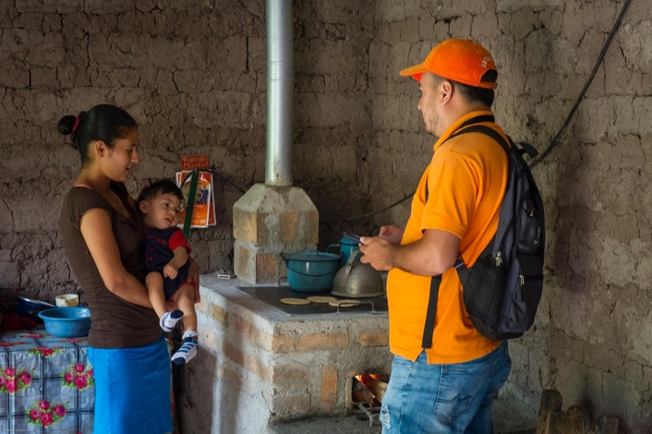
Figure 1: New Dos por Tres stove
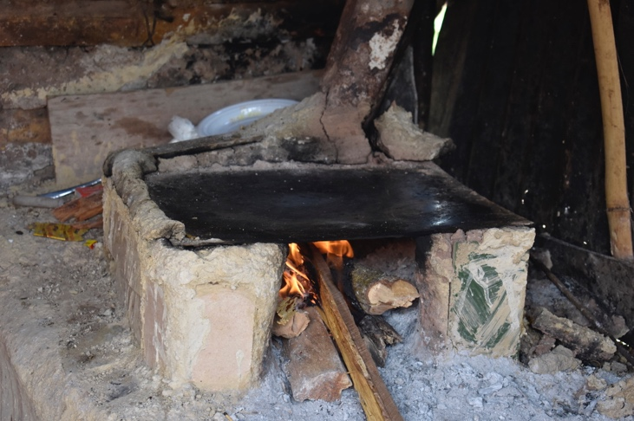
Figure 2: Traditional fogón stove

To scale the project, Proyecto Mirador pioneered a Programa de Ejecutores, a franchise-like social enterprise system in which entrepreneurs are paid to build stoves on behalf of Proyecto Mirador. To build more stoves Mirador only has to add more Ejecutores (microenterprise stove building contractors). Mirador first reviews its solicitations to select and allocate areas and quotas to each Ejecutor. Each Ejecutor, after being rigorously trained by Mirador, collects the stove construction materials from Proyecto Mirador, organizes his or her team of stove builders, works closely with local municipalities to establish a construction schedule, builds stoves and provides training to stove beneficiaries. Our Ejecutores earn far in excess of a typical professional wage, but each is subject to Mirador’s rigorous verification and future quotas are dependent on quality performance under Mirador regimes.

Based on the experience of the First VPA, the stoves are highly successful from the perspective of health improvement and wood savings, and the Second VPA seeks to increase production of Dos por Tres stoves in Guatemala going forward. Relying on charity to underwrite the organization is not sustainable. Long-term and stable funding does not exist for the significant expansion of stove distribution. Relying on additional donor support is not a viable long-term option. In the long run, carbon finance is a realistic source of sustainable funding that enables the enhanced distribution of Dos por Tres stoves to proceed. Mirador markets Gold Standard voluntary carbon credits (VERs) in order to provide long-term, sustainable funding.

With the help of carbon finance Mirador will continue to accelerate distribution of Dos por Tres stoves in Central America. The use of carbon finance will ensure Mirador can continue under a self-sustaining, market-driven business model rather than one that relies extensively on charitable donations.

All stove beneficiaries are clearly informed of Proyecto Mirador’s ownership of the carbon savings
from each stove. To accomplish this, Mirador distributes a Use & Maintenance Brochure to each
stove beneficiary at the time of stove construction. The Use & Maintenance Brochure includes a
statement regarding rights to ownership of emission reductions, which reads as follows (English
translation): “By accepting a new stove from Proyecto Mirador, you agree that the CO₂ reductions created by the stove are the property of Proyecto Mirador.” This caveat is also explained at the community meetings Mirador conducts in each village prior to starting construction.

Figure 3 below shows the original La Justa stove; Figure 4 shows the Dos por Tres cookstove
which Mirador has adapted to maximize emissions reductions and support broader dissemination
of the stoves.

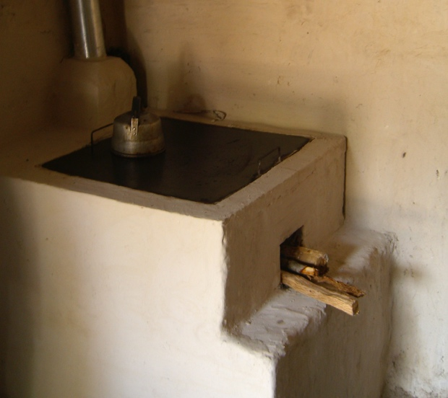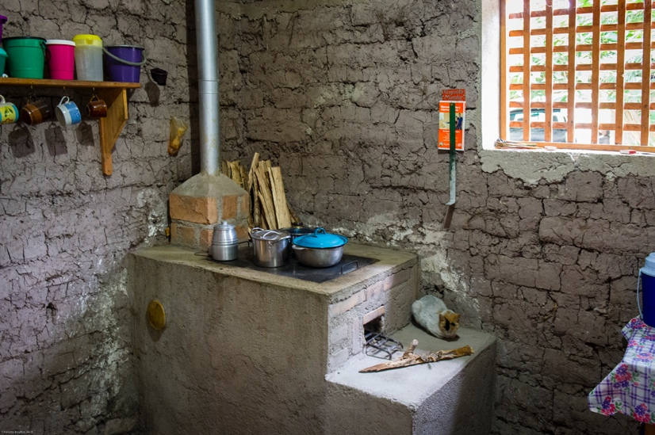
Figure 3: Original La Justa stove Figure 4: Dos por Tres stove

When wood burns it releases a number of compounds into the atmosphere, including CO₂, methane, nitrous oxide, and particulate matter consisting of both elemental carbon (or soot) produced in flaming fires and organic carbon produced in smouldering fires. Elemental carbon
(EC) has a global warming potential 680 times that of CO₂. By burning fuel efficiently and completely, the Dos por Tres reduces the amount of soot or black carbon found in Particulate Matter and Products of Incomplete Combustion (PICs) as well as reduces the amount of Particulate Matter and PICs produced overall.

Globally, indoor air pollution kills more people each year than malaria and causes almost as many
deaths as unsafe water and sanitation. In traditional wood burning stoves, wood fuel emits substantial amounts of 26 hazardous air pollutants. Fine respirable particles less than 2.5 microns
are able to penetrate deep into the lungs. These compromise the body’s defense systems and its ability to filter and remove toxic particles. Women and children are the most harmed by inefficient
stoves because they do most of the cooking. Because women also care for the children, the children also suffer a high level of exposure. Indoor air pollution also has an effect on unborn children similar to smoking during pregnancy.

The aim of our project is to serve as a model for other organizations that wish to initiate similar
stove projects, thus bringing the numerous benefits of fuel-efficient cookstoves to potentially
millions of people.

    - Eligibility of the project under approved PoA

>> (Demonstrate how each VPA meets the eligibility criteria as defined in approved PoA)
# | Eligibility Criteria | Description | Means of Verification (as defined in PoA) | Proof of Eligibility  (this VPA)
1 | VPA Location and Project Boundary | VPA shall involve the distribution of ICS within the geographical boundary of Host Countries defined in the PoA. | V PA-DD clearly states VPA project boundary under Section A.4, “Geographic Reference or Other Means of Identification,” and VPA project boundary falls within PoA project boundary.  GPS markings are kept for each stove installed and available to VVB for verification to ensure all stoves are within VPA project boundary. | VPA clearly states VPA project boundary under Section A.4, “Geographic Reference or Other Means of Identification.” VPA project boundary is Guatemala, which falls within PoA project boundary.  GPS markings are kept for each stove installed and available to VVB for verification to ensure all stoves are within VPA project boundary
2 | Avoid double counting | VPA shall apply a unique identifier to each cookstove installed and apply routine data checks and other management protocols that ensure double counting is avoided. | Electronic database is available to VVB for verification containing individual records for each stove, each with a unique identifier automatically generated by database. | Stoves are built in situ and a unique household account is created in the electronic database at the time of construction, including a GPS mark. Furthermore, an inspector goes to each house before construction can begin and at that time, verifies that ICS technology is not already present. For those reasons, if there is another similar activity within the same target area, stoves from the other project cannot possibly be counted under Mirador’s activity.
3 | Technology | VPAs shall utilize ICS technologies with useful energy output of less than 150kW. | Technical report from qualified 3rd party. | Each stove installed has continuous useful energy outputs of less than 150kW per unit, as provided (per Aprovecho, 2009).
4 | Start Date | The start date of each VPA shall be the first date of stove construction. | All stove installations are individually tracked on an electronic database that is available to VVB for validation. | Start date of this VPA is 13 May, 2019. All installations from the project start date and forward are in the Mirador stove database and available for VVB review.
5 | Methodology | VPA uses approved Gold Standard Methodology Technologies and Practices to Displace Decentralized Thermal Energy Consumption, Version 2.0, and satisfies all its requirements. | VPA-DD states methodology used under Section B.1, under “Reference of methodology(ies) and standardized baseline(s).” | Section B.1 of VPA-DD states methodology used as “Thermal Practices to Displace Decentralized Thermal Energy Consumption, Version 2.0.”  Applicable requirements are substantiated as follows:  - Project boundary is clearly identified in Section A-4 of VPA-DD and agrees with PoA project boundary.  - VPA confirms that technologies counted in the project are not included in another voluntary market or CDM project activity.  - Appropriate mechanisms are in place to prevent double counting (see explanation in this chart, above).  - Each stove installed has continuous useful energy outputs of less than 150kW per unit, as provided (per Aprovecho, 2009).  - As a precondition for the installation of ICS, beneficiaries are required to remove the traditional stove that is being replaced.  - PP clearly communicates to all beneficiaries, verbally (in training sessions) and in writing (in the Use & Maintenance Brochure), that the ownership of emission reductions shall reside with the CME. Use and Maintenance brochure has been supplied to the VVB for confirmation.
6 | LSC | VPA shall conduct an LSC that follows the GS LSC guidance | LSC report | The LSC is conducted at the VPA level. The Second VPA held its LSC meeting in 27/02/2020.
7 | EIA | EIA shall be conducted if required by the host country | Official documentation confirming EIA conducted | EIA is not required by the host country. Informal environmental assessment is provided at the PoA level.
8 | Target group | VPAs shall target household or institutional users of inefficient biomass stoves.  Users may or may not include auxiliary non-biomass cookstoves to augment their cooking practices. | To be confirmed via baseline kitchen surveys, conducted according to the requirements of the GS methodology. | To be confirmed via baseline kitchen surveys that target users are household users of inefficient biomass stoves. Mirador verifies, before installation, that each stove user is a household user of a traditional fogón.
9 | Additionality | VPA must demonstrate that the project meets additionality requirements of the Gold Standard. | VPA demonstrates additionality using the Investment Barrier Analysis.  Analysis shall be structured to include three potential sources of income:  - Equity investment upon expectation of certain returns  - Financing institution (bank) in the form of a bank loan  - Donations  Each potential source of income shall be analyzed from the perspective of three potential project developers:  - Individual households  - Governmental Institutions  - Private organizations  By exploring the potential of the above three sources income from those three perspectives, VPA shall show that in the absence of project activity, baseline conditions (installation of the traditional cookstove) would persist. | VPA demonstrates additionality using Investment Barrier Analysis. VPA demonstrates that in the absence of project activity, baseline conditions (installation of the traditional cookstove) would persist. The elaborated arguments to demonstrate the additionality in line with this criterion are provided in the section B.5 of this VPA-DD.
10 | Ownership of ER credits | VPA shall be developed and implemented by the CME. In case contracted entities are retained to manage future VPAs, the contractual agreements between each partner and the CME will clearly establish ownership of emission reduction credits generated through the PoA as belonging to the CME.  VPA shall clearly communicate to all end user beneficiaries, verbally and in writing, that the ownership of emission reductions shall reside with the CME. | VPA-DDs shall be approved by the CME and submitted by CME to VVB for inclusion.  VPA is managed by CME. In case contracted entities are retained to manage future VPAs, contracted entities shall confirm to VVB their agreement that emission reduction credits generated by the VPA through the PoA belong to the CME.  VPA shall present training brochures and procedural training materials to show that final beneficiaries are clearly informed that the ownership of emission reductions shall reside with the CME. | This VPA is submitted directly by the CME to VVB for inclusion. VPA is managed by CME, so it is clear ERs are owned by CME.
11 | ODA | If official development assistance (ODA) is provided, it is not contingent on transfer of carbon credits to the donor country providing ODA support. | Completion of ODA Declaration form, if required | ODA Declaration Form has been submitted to GS.
12 | Sustainable Development | VPA is required to align with the Sustainable Assessment as defined in the GS4GG Transition Annex. | CME shall directly review VPA for compliance and if any negative indicators are present, modifications will be required until all indicators score positive or neutral. | The VPA aligns with the Sustainable Development GOAS outcomes as described in the GS4GG Transition Annex and articulated in detail in section B.6 of the VPA-DD.
13 | Prior consideration of carbon revenues | VPA is required to demonstrate that real actions were taken to secure carbon revenue for the project in parallel with its implementation. | Evidence to support this should include one or more of the following: contracts with consultants for services related to GS compliance; draft versions of PDDs; evidence of agreements or negotiations with a VVB for validation services, or earlier correspondence with the Gold Standard regarding the project. | The VPA has been submitted within a year of the start date of the project activity.

General Eligibility Criteria of Gold Standard for Global Goals
Eligibility Criteria
Project type | End-use energy efficiency (Improved cookstoves).
Project Location | The country of Guatemala
Project Area, Project Boundary and Scale | The project area and boundary includes the entire country of Guatemala.  This boundary also hosts the baseline and project fuel collection area.  The ICS of the project will be identified in order to avoid double counting with overlapped activities in the project area.  This is a large scale activity. No specific requirement due to the scale of the activity.
Host Country Requirements | The project is in compliance with the host country’s legal, environmental, ecological and social regulations. No specific requirents from the host country have bee identified regarding activities at household level.
Contact Details | Esther Adams, Program Manager (eadams@proyectomirador.org)
Legal Ownership | The carbon transfer forms from project beneficiaries are collected transparently with full, prior, and informed consent (FPIC). The carbon transfer form will be made available for the design certification and at the performance review.
Other Rights | NA.
Official Development Assistance (ODA) Declaration | ODA Declaration submitted.

    - Legal ownership of products generated by the project and legal rights to alter use of resources required to service the project
>> (Justify that project owner has full and uncontested legal ownership of the products that are generated under Gold Standard Certification and has legal rights concerning changes in use of resources required to service the Project for e.g water rights, where applicable.)

Project beneficiaries are consistently informed that Proyecto Mirador owns all carbon credits issued as a result of emission reductions from all stoves installed. This is first articulated at the Community Meetings staged before stove construction begins in each area, then reiterated when beneficiaries are individually trained. The Mirador Use and Maintenance Brochure, which is given to stove beneficiaries after stove installation, also includes a written statement of Proyecto Mirador’s ownership of carbon credits, and the consent of all beneficiaries is required as a precondition to stove installation.

"By accepting a new stove from Proyecto Mirador, you agree that any reductions in CO₂ emissions created by the stove are the property of Mirador."

All Follow-up Visits are scheduled systematically following Proyecto Mirador’s scheduled stove installation cycle to ensure proper timing for follow-up.
    - Location of project
      - Host Country
>>
Guatemala
      - Region/State/Province etc.
>>
The entire country of Guatemala is considered as the project area.

      - City/Town/Community etc.
>>
The entire country of Guatemala is considered as the project area.

      - Physical/Geographical location
>> (Include information allowing the unique identification of this project.)

The entire country of Guatemala is considered as the project area.

    - Technologies and/or measures

>> (Describe the technologies and measures to be employed and/or implemented by the project, including a list of the facilities, systems and equipment that will be installed and/or modified by the project. Include information essential to understand the purpose of the project and how it will contribute positively to three SDGs.)

Under the Second VPA, Proyecto Mirador’s Dos por Tres improved cookstove (ICS) technology is implemented for household applications.

The Dos por Tres stove uses rocket stove technology to optimize the cooking temperature across the plancha, or griddle. Fuel is burned in the rocket combustion chamber and an efficient draft is formed which spreads heat across the plancha and vents the smoke out of the house through the chimney.

The Dos por Tres maximizes the reduction of greenhouse gas emissions through its efficient design and structural improvements. Compared to other alternative stoves, the Dos por Tres Stove is, at the same time, the most effective substitute, and easily assimilable as a replacement for the traditional stove.

Figure 5: Traditional fogón vs. Dos por Tres under thermal Flir® camera

The life span has been proven since the original project registration in 2009, in some cases, stoves were found still in use after 10 years. As a conservative measures, all the stoves are discarded for the emission reduction calculations after the sixth year in use. During all the stove lifetime, the stove aging and the drop-off rate for all the age groups are accounted.

A table in section B.6.1 summarizes how the project provides positive impacts to the SDGs.

    - Scale of the project

>> (Define whether project is micro scale, small scale or others. Justify the scale referring to relevant activity requirement.).

The PoA has been registered as a large scale programme. The Second VPA adheres to the same scale.
    - Funding Sources of project

>> (Provide the public and private funding sources for the project. Confidential information need not be provided.)

Long-term and stable funding does not exist for the significant expansion of stove distribution. Relying on donor support is not a viable long-term option. In the long run, carbon finance is a realistic source of sustainable funding that enables the enhanced distribution of cookstove stoves to continue. Mirador markets Gold Standard carbon credits from verified reductions of unsustainably harvested fuelwood in order to provide long-term, sustainable funding. Mirador’s reliance on carbon offsets enables the project to serve the poorest of the poor.

  - Application of selected approved Gold Standard methodology
    - Reference of approved methodology
>>

The methodology, Technologies and Practices to Displace Decentralized Thermal Energy Consumption, Version 2.0, is applied and is applicable to the project, in which low-emission cook-stoves and regimes (Dos por Tres stoves) replace relatively high-emission baseline scenarios (traditional fogón stoves) in Guatemala). The baseline is defined based on the assumption that in the absence of Mirador’s activity, all households in the community would continue to utilize the baseline stove. Their fuel consumption is defined in the KPT and applicable to the entire population. A standardized baseline is not employed.

The methodology states, under “Section I: Source and Applicability”:

This methodology is applicable to programmes or activities introducing technologies and/or practices that reduce or displace greenhouse gas (GHG) emissions from the thermal energy consumption of households and non-domestic premises. Examples of these technologies include the introduction of improved biomass or fossil fuel cookstoves…

    - Applicability of methodology
>> (Justify the choice of the selected methodology(ies) by demonstrating that the project meets each applicability condition of the applied methodology(ies))

The five applicability conditions of the Methodology are met by Mirador as follows:

1. The project boundary is clearly identified as Guatemala. Stoves are built in situ and a unique
household account is created in the electronic database at the time of construction, including a GPS mark, so that if there is another similar activity within the same target area, stoves from the other project cannot possibly be counted under Mirador’s activity. Likewise, Mirador stoves are not portable, so they cannot be confused with stoves disseminated by another project.

2. The Dos por Tres has continuous useful energy outputs of less than 150kW per unit.

3. As a precondition for the installation of the Dos por Tres, beneficiaries are required to remove the traditional stove that is being replaced. Beneficiaries are made aware of the requirement to remove the traditional cookstove at the time they sign up to receive the stove. Also, during Mirador’s training exercises, Stove Technicians require the beneficiary to remove the traditional stove. Every time a Supervisor performs a follow-up visit to a household post-installation, the Supervisor enters basic data related to stove condition and maintenance and verifies user information. That data is entered using a handheld device and is used by Mirador Supervisors and Ejecutores to schedule additional training or repairs, if needed, and to streamline operations. At that time, the Supervisor checks to verify the traditional fogón has been destroyed and records the result, making a note on the account to follow up if that has not yet happened.

4. PP clearly communicates to all beneficiaries, verbally (in training sessions) and in writing (in the Use & Maintenance Brochure), that the ownership of emission reductions shall reside with the CME. Agreement to acknowledge Mirador’s ownership of ERs is a precondition to receiving a stove.

5. Project activity does not make use of a new biomass feedstock in the project scenario, so the 5th applicability condition does not apply to Mirador.

Baseline values will be defined via the KPT. Field results are adjusted to account for moisture variation and adult equivalent persons. Any lab testing involves tending to replicate stove use as would be done by cooks.

The KPT will focus exclusively on typical baseline fogón stoves, and involve taking physical measurements of daily wood consumption with the required return visits over a four-day period.

As per the provisions of the TPDDTEC v2, Section 7, Performance Field Tests and Calculation of Emission Reductions, The baseline and project performance field tests (BFT and PFT) measure real, observed technology performance in the field. Consumption is measured with a representative sample of end users under the defined baseline scenario (in the absence of project technology) and project scenario using the Kitchen Performance Test (KPT). Robust sampling will be employed; testing is transparent, easily replicable and conservative; and the impact of day-to-day variation in cooking practices is accounted for in the calculation of emission reductions on absolute fuelwood savings as observed in the KPT over a complete four-day cycle.

Seasonal variation will be considered for the baseline KPT. All baseline and project field testing will be designed to satisfy the “90/30 rule” as described in the methodology.

Projected emission reductions are calculated according to Equation 1 in Technologies and Practices to Displace Decentralized Thermal Energy Consumption, Version 2.0, as follows:

ER_{y} = Σb,p (N_{p,y} * U_{p,y} * P_{p,b,y} * NCV_{b,fuel} * (f_{NRB,b,y} * EF_{fuel,CO2} + EF_{fuel,nonCO2})) – Σ LE_{p,y} (1)

Accordingly, key data are monitored as follows:
N_{p,y} Parameter ID6
Cumulative number of project technology-days included in the project database for project
scenario p against baseline scenario b in year y

U_{p,y} Parameter ID8
Cumulative usage rate for technologies in project scenario p in year y, based on cumulative
adoption rate and drop off rate revealed by usage surveys (fraction)

P_{p,b,y} Parameters ID7
Specific fuel savings for an individual technology of project p against an individual technology of
baseline b in year y, in tons/day, as derived from the statistical analysis of the data collected from the field tests

f_{NRB,b,y} Parameter ID5
Fraction of biomass used in year y for baseline scenario b that can be established as non-renewable Biomass

NCV_{b, fuel} Parameter ID4
Net calorific value of the fuel that is reduced

EF_{fuel,CO2} Parameter ID1
CO₂ emission factor of the fuel that is reduced

EF_{fuel,nonCO2} Parameters ID2 & ID3
Non-CO₂ emission factor of the fuel that is reduced

LE_{p,y} Parameters ID9 & ID10
Leakage for project scenario p in year y (tCO₂e/yr)

Emission reductions are calculated by comparing daily fuel consumption per person-meal, adjusted for variations in moisture content, in the project scenario vs. baseline scenario. Calculations are based on absolute fuelwood consumption, the quantity of secondary fuel is treated as zero and emission reductions are calculated on the basis of reduction of only the primary fuel.

Non-renewable biomass (NRB) will be calculated on time for VPA validation.

A complete emission reduction calculation spreadsheet will be provided to the VVB at the time of Validation. Actual stove build figures are used up to the time of initial VPA submission to the VVB; estimated stove build figures are applied thereafter.

Unless otherwise specified by GS, the PoAs and its VPAs follow the requirements listed in the CDM Project Standard for Programmes of Activities.

    - Project boundary

>> (Present a flow diagram of the project boundary, physically delineating the project, based on the description provided in section A.5 above.)

The project boundary includes the physical site where the baseline and project cookstoves are installed, as well as the fuel collection area as described in the section A.5 above.

The project boundary is defined as the geo-politic territory of Guatemala.

The following diagram physically delineates the project boundary:

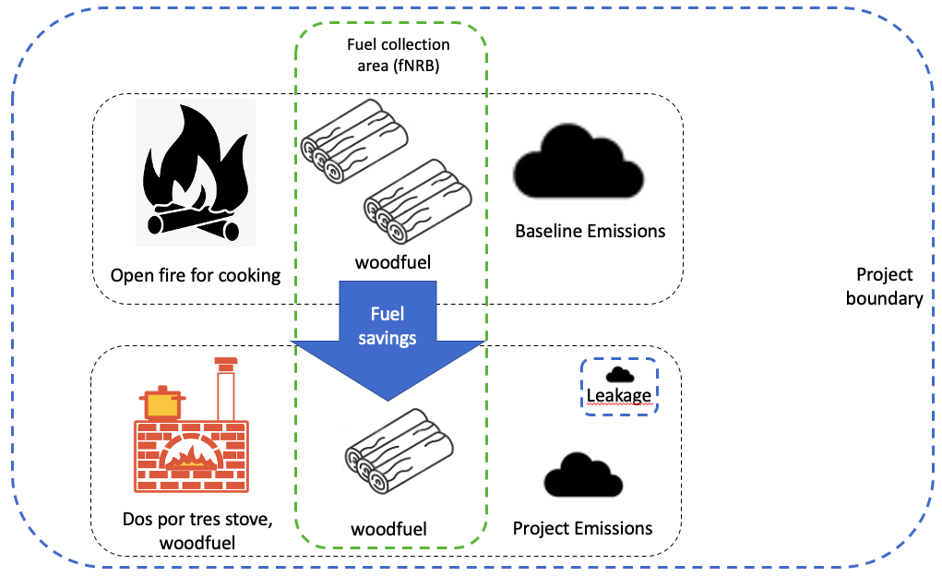
Figure 6. flow diagram of the project boundary

For the purpose of GHG mitigation/sequestration following table shall be completed (delete if not required)
Source |  | GHGs | Included? | Justification/Explanation
Baseline scenario | Source 1 | CO₂ | Yes | Main emission source
Baseline scenario | Source 1 | CH₄ | Yes | Relevant source of emissions
Baseline scenario | Source 1 | N₂O | Yes | Relevant source of emissions
Project scenario | Source 1 | CO₂ | Yes | Main emission source
Project scenario | Source 1 | CH₄ | Yes | Relevant source of emissions
Project scenario | Source 1 | N₂O | Yes | Relevant source of emissions

VPA is confined to Guatemala, located within the geographical boundary of the registered PoA.

    - Establishment and description of baseline scenario
>> (Explain how the baseline scenario is established in accordance with guidelines provided in GS4GG Principles & Requirements and the selected methodology(ies). In case suppressed demand baseline is used then same should be explained and justified.)

Baseline Stove
The baseline stove is identified as a relatively high-emission traditional fogón stove, usually with no chimney or grate. In some cases, the traditional fogón stove may include a chimney or grate, but typically those are not designed to optimize the fuel consumption and in all cases, lack proper structural design (no rocket combustion chamber, nor efficient air flow). The different types of inefficient baseline stove model include:

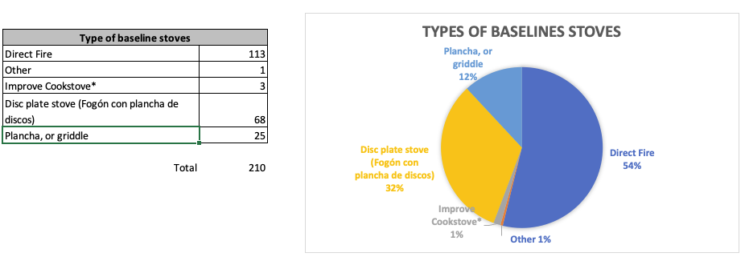Figure 7. Baseline Survey Results, Type of baseline stove.
* the users of improved cookstove indicated the stove was in bad shape

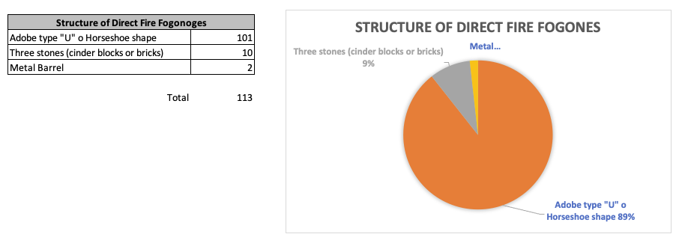
Figure 8. Baseline Survey Results, Structure of direct fire fogones

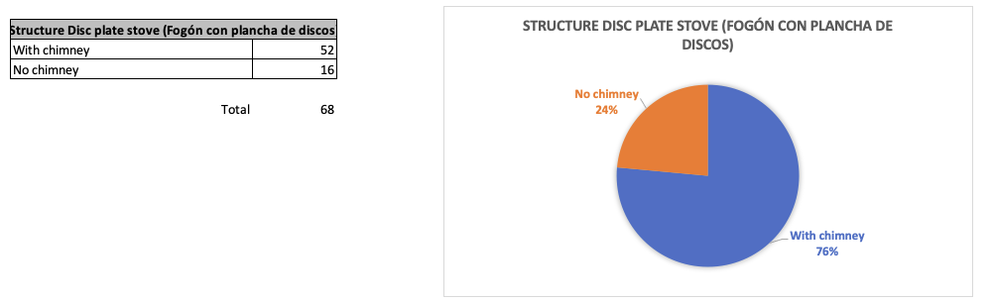
Figure 9. Baseline Survey Results, Structure of disc plate stoves

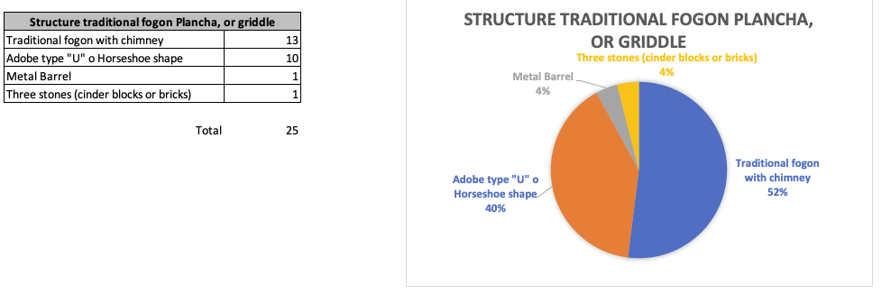
Figure 10. Baseline Survey Results, Structure of traditional fogon plancha or griddle

All the households (100%) included in the baseline survey use firewood as the main fuel for cooking. This is a requirement for participating in the project. No one (zero %) declared that they use another type of stove (gas or electric).

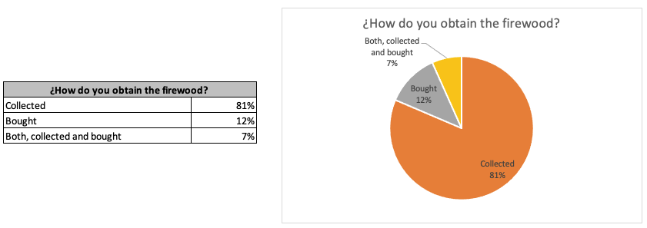
Figure 11. Baseline Survey Results, How firewood is obtained.

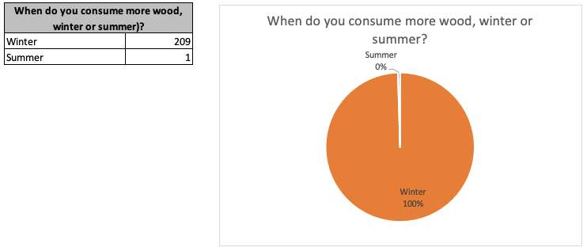
Figure 12. Baseline Survey Results, Seasonal consumption.

The baseline survey also includes the collection of the following fields:
- Address (town and GPS coordinates)
- Mobile/land line (whenever available)
- Government ID
- Number of people served by baseline technology
- Frequency of use of baseline technology
- Other technology in use (electric or gas stoves)
- Sources of fuel
- Baseline stove picture
- Location of the baseline stove (kitchen, outside, etc.)
- Uses for space heating
- Specific uses (e.g. roast maize, coffee, food for selling, etc.)
- Impressions about baseline stove (like/dislike)
- Fuel collection including frequency, time spent, person in charge

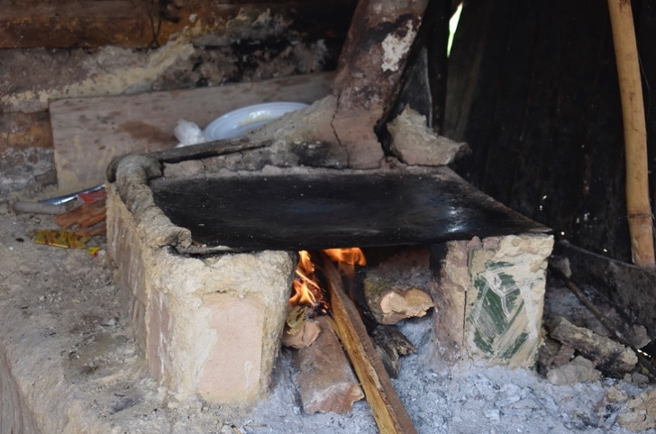
Figure 13: Traditional fogón stove

Project Implementation Modality
Proyecto Mirador does not charge cash to install the Dos por Tres Improved Cookstove. The project supplies the main components of the stove including: the steel plancha (cooktop), aluminium chimney, parilla (steel grill support for firewood), steel cleaning device (“El Cinco”), ceramic parts and skilled labour force. As counterpart, the project beneficiaries are required to prepare a fixed base for the stove and to contribute some materials for the stove construction including: cement or adobe, gravel, steel wire, empty reused can and ashes.

Stoves are built in situ and a unique household account is created in the electronic database at the time of construction, including a GPS mark, so that if there is another similar activity within the same target area, stoves from the other project cannot possibly be counted under Mirador’s activity. Likewise, Mirador stoves are not portable, so they cannot be confused with stoves disseminated by another project.

The project operates under the premise of “No Cuesta No Cuida” ("if it doesn't cost, it isn’t cared for"). The contribution of time and materials made in kind by the end-users enhance that premise. The financial model of the project relies on carbon offsets as explained in the VPA-DD.

Target Area of the Baseline Survey (location where the surveys were carried out)
VPA2, Guatemala: Department of Chiquimula, towns of Chiquimula and Esquipulas.

Survey date:
VPA2, Guatemala: From 17/08/2020 08/10/2020

Proyecto Mirador will continue to serve the poorest, rural areas of Guatemala and Nicaragua.

Sampling and Data Collection Process

The baseline survey included 210 samples for Guatemala and 299 samples for Nicaragua. The methodology indicates a minimum sampling size of 100 for group size higher than 1000. Although the final group size is not yet known because the project activity includes progressive installation throughout the creditiong period, the sample size for baseline surveys done for both VPAs is much higher than the minimum required by the methodology.

Representativeness
The selected households to participate in the baseline survey should meet the following requirements:

- To use a traditional fogon as main cooking method.
- Attend the socialization meeting and project training and agree with the project maintenance program.
- Permanently destroy the traditional fogon right before the Dos por Tres stove is built.
- Agree to relinquish any rights to carbon credits generated by the installation of the stove.
These requirements ensure that the households are representative of the baseline target group of rural areas.

The data collection was performed in the field with mobile phones using the TaroWorks app, which transmits the inputs directly to the Salesforce.com database. The original and raw data are available upon request. For all the records, the data collected included ID, GPS coordinates, phone number, and a picture of the stove and the person surveyed.

The following information has been gathered for the project activity to determine the baseline scenario:
- Project non-renewable biomass (NRB)
- Baseline survey (KS) of target population characteristics
- Baseline Kitchen Performance Test. The results of the test will be made available on time the verification.

The baseline scenario reflects that each household uses a traditional fogón stove prior to becoming a project beneficiary, and assumes that installation of the new improved stove has not yet occurred. This scenario is captured by assessing fuelwood supply, consumption patterns and environmental behaviours among households that use traditional wood stoves. These data define the baseline situation, which we use to characterize conditions that would prevail in the absence of the project activity. The baseline is defined based on the assumption that, in the absence of Mirador’s activity, all households in the community would continue to utilize the traditional fogón. Their fuel consumption is defined in the Kitchen Performance Test, discussed separately, and is applied to the entire population. The stoves are installed progressively during the crediting period.

Changes in the baseline scenario during the crediting period for this VPA are not expected by the project participants, for the following reasons:
- The direct fire traditional fogón model of stove is common to prevalent throughout the PoA project area.
- Current demand in the project area among fogón users far exceeds Proyecto Mirador’s performance capacity and Mirador does not expect to run out of potential beneficiaries under this baseline scenario.
- Abject poverty in the rural sector is prevalent and Proyecto Mirador will continue to serve the poorest, rural areas of Guatemala.

Since the baseline social, economic, and environmental conditions are not likely to consistently improve during the crediting period, a fixed baseline will be used for the duration of the crediting period.

    - Demonstration of additionality
>> (If the proposed project is not a type of project that is deemed additional, as stated below, then follow guidelines in section 3.5.1 of GS4GG Principles & Requirements to demonstrate additionality.)

As explained in section A.1 The project began operation as a Gold Standard project under a stand-alone PDD limited to Honduras. In 2012 the project in Honduras was upgraded to a PoA, with the project activity in Honduras included as the first VPA. During subsequent years the first VPA has continued the same project activity under the Gold Standard PoA, which was upgraded to TPDDTEC methodology in 2016. As part of the international expansion of the PoA, the Second VPA, in Guatemala is being proposed and Proyecto Mirador continues to build the Dos por Tres stove model wherever similar baseline conditions exist within Guatemala. The new activity proposed in Guatemala demonstrates to be additional using Investment Barrier Analysis.

In line with the eligibility criteria No. 9, this VPA demonstrates additionality using Investment Barrier Analysis. Through the arguments below, VPA demonstrates that in the absence of project activity, baseline conditions (installation of the traditional cookstove) would persist.

The development and expansion of our stove project is dependent on the extra income from the sale of carbon credits that will be generated once carbon certification from the Gold Standard is secured. Without an external revenue stream from selling carbon credits, the entire enterprise is deeply cash flow negative and would eventually halt due to lack of funds.

The VPA demonstrates additionality using the CDM Tool for the demonstration of additionality, version 7.0.0.

Step 1. Identification of alternatives to the project activity consistent with current laws and regulations

Sub-step 1a. Define alternatives to the project activity

There are two realistic and credible alternatives to the proposed project activity:

Alternative A: Continue cooking on the fogon stove. No investments needed.
Alternative B: Implementation of the project without GS VER revenues.

The alternative of implementing the project under a sales-based approach was not considered because the significant difference with the proposed project activity. The significant difference between other ICS projects observed in the host countries and the project proposed is that Proyecto Mirador does not sell the stoves. The project’s beneficiaries contribute ‘in kind’ with some materials but no payments take place. Given this substantial difference, any comparison against sales-based project would not be applicable. Although other ICS projects may provide a similar service for cooking needs, from the investors’ point of view–which is the focus of the analysis–these other projects cannot be compared with the proposed project activity. This is the reason why other ICS projects were not listed as realistic and credible alternative scenarios.

Furthermore, another substantial difference is that sales-based ICS projects, in virtually all cases, do not include monitoring. The cost of the monitoring program, including supervisory visits, surveys, kitchen performance tests, and the development and maintenance of a highly customized digital database built on the Salesforce.com platform, can only be afforded with the income from carbon revenues. On the other hand, the lack of monitoring to ensure adoption and usage will result in abandonment of the ICS technology, meaning the user returns to the traditional cooking method. The same logic applies for the GS TPPDTEC methodology; unless it is demonstrated that the ICS is still in use, it is assumed that the beneficiary has returned to the cooking practice identified in the project scenario
From the investor perspective, it is not relevant to compare these contrasting alternatives. The proposed project activity does not generate income aside from the carbon credits, and the training and monitoring cost is significantly high, making the alternatives not financially attractive.

Sub-step 1b. Consistency with mandatory laws and regulations

In Guatemala there is no law or regulation that applies to the efficiency of cooking stoves. There is no legislation in Guatemala that requires the use of efficient stoves, and none is expected to be introduced during the project period.

The two alternatives identified comply with current law and regulations. There is no law or regulation that prohibits to use traditional fogones or other inefficient combustion methods for cooking, nor, there are regulations or efficiency acceptance level for improved cookstoves in Guatemala.

Step 2. Financial analysis
Sub-step 2b: Option 1. Apply simple cost analysis.

For a project activity that produces no revenue other than carbon credits, “simple cost analysis” is the appropriate analysis to perform. Therefore, we will briefly document below the costs associated with the project activity and the alternatives identified in Step 1, and demonstrate that there is at least one alternative – “traditional fogon stove cooking” – which is less costly than the project activity. We can clearly meet the test that the proposed project activity is more costly than at least one alternative.

It has been shown that despite the availability of the new stove technology and building materials, Guatemalans on their own do not invest in the installation of efficient stoves or other similar wood saving stoves in the absence of external funding. Advancing the installation of improved stoves relies primarily on charitable donations or grants.

Proyecto Mirador’s current cost per stove is roughly US$ 60. Mirador also asks households to contribute to the stove, to create a sense of “ownership.” To that end, stove beneficiaries add ‘in-kind’ inputs of labor, and materials, which are estimated at a current value of US$ 17 per stove. Mirador considers this sharing of the investment to be a critical component to the success of the project.

Clearly, at US$ 60 per stove, the proposed project activity is more costly than the alternative of “traditional fogon stove cooking” which assumes that households continue to use existing stoves.

Step 3. Barrier analysis
For the demonstration of additionality, barriers are identified which demonstrate that the project activity would not have occurred anyway due to at least one barrier. The most common barriers are: investment barrier; technological barrier; barriers due to prevailing practice. We discuss how the availability of GS VER revenue helps the project overcome these barriers that would otherwise prevent the project activity from occurring.

Sub-step 3a. Identify barriers that would prevent the implementation of the proposed GS VER project activity

Potential sources for such funding from individual household beneficiaries, government institutions, or private non-governmental or business organizations are as follows:
- The households which receive a Dos por Tres Stove
- Donations from non-governmental organizations (NGOs)
- A financing institution (bank) in the form of a bank loan against the collateral of expected sales of carbon credits
- International donations from individuals
- The Guatemala local, provincial or federal governments
- Creating a business that sells stoves

The identified possibilities are all non-viable. Examples of this are the multiple, isolated government programs such as FIS, FONAPAZ, FODIGUA which lack systematization, donating the stoves with minimum participation of beneficiaries. The chart below analyzes the three possible sources of funding (equity investment, loan financing, and donations) and assesses their viability from the perspective of individual households, governmental institutions and private organizations (whether businesses or NGOs). The conclusion is that without an external source of funding from the sale of GS VERs, the distribution of Dos por Tres cookstoves will not be able to expand.

The proposed project activity does not generate income different to the carbon credits and the training and monitoring costs are significantly high. From the investor perspective the project proposes is not financially attractive, therefore, as explained above, the barriers faced prevent this alternative.

Since no investments needed for the alternative of continue cooking on the fogon stove, there are not barriers that prevent this alternative scenario.

Source of funding | Project developer
Source of funding | Individual households | Governmental Institutions | Private organization (business  oriented or  non-profitable)
Equity  investment  upon  expectation  of certain  returns (i.e.  tangible or  intangible) | Guatemalans on their own do not invest, or invest very little in the installation of new efficient stoves. Guatemalan household income doesn’t support purchase of the stove, particularly among the poorest of the poor. Efforts done in the past by the government remain isolated.  The unlikeliness of individual households making an equity  investment is best evidenced by the lack of people who have approached us on an individual basis to buy the Dos por Tres cookstove.  This reflects a lack of understanding of the savings involved, as well as a lack of interest in getting rid of indoor air pollution, which in turn reflects a lack of knowledge about the danger it poses to their health. This also illustrates the fact that individuals cannot allocate funds to slow deforestation and forest degradation or make an impact on slowing global warming. This is particularly true in the villages where we operate, which are far from urban centers and represent the poorest of the poor.  To further illustrate, frequently the citizens of the communites approached did not purchase and install the ‘Dos por Tres’ stoves on their own despite the high level of satisfaction among ‘Dos por Tres’ stove owners and Mirador‘s willingness to sell the ‘Dos por Tres’ stoves at cost. Even the wealthy in some communities have not  purchased the improved stoves without Mirador’s assistance. | It is demonstrated that local authorities (not to mention central government) do not have designated budgets for this type  of program. The scarce funds they manage to invest are assigned to other priorities such  as improving roads,  electrification, and providing water.  Local municipal governments in  limited cases have supported our work. For example, they have  provided warehousing for our materials for free, and in some cases they have contributed part of the distribution costs that comprise between 10-15% of our contribution.  But in no case has a local municipal government been in a position to fund the total cost of the dissemination of the stoves. In no case has a local, provincial or national government program given Mirador any financial support besides non-cash services. Our 16 years of experience have shown that municipal governments do not have budgets for this type of work. | In many countries, businesses have been created to sell stoves. The problem is that in the poorest areas, people do not have hard cash with which to buy them, or income levels to support purchase, or access to the cities where the stoves are distributed. Therefore, this becomes an unattractive course  of action for entrepreneurs who  might be interested in selling stoves to the rural poor of Guatemala.  The feasibility of attracting private businesses into the stove business in Guatemala is hindered  by the lack of cash resources of customers, the lack of awareness of customers of the cost of indoor air pollution and the lack of awareness of the dangers of  either deforestation or global warming. It is also hurt by the  requirement to fund the bulk of the US$ 60 per stove without any real willingness on the part of its customer base to pay an amount in excess of US$ 17, the approximate value of the beneficiaries’ contribution of raw materials. These facts make the business a very unprofitable  operation.  Attracting private businesses that could fund the losses with  carbon credits might someday be possible, but the direct upfront  cost of certification makes the business untenable. With local salaries in rural Guatemala of US$ 4.00/day,  customers and potential entrepreneurs do not have sufficient resources.
Financing  institution  (bank) in the form of  a bank loan | The rural poor of Guatemala do not have access to bank credit  and there is no banking  institution that makes credit  available to the project  beneficiaries.  Active loan rates for June 2009 were reported by the Central Bank of Guatemala as 1.75%. Interest Rates are around 12.7% commercial banks which makes the cost of borrowing prohibitive. Furthermore, in Mirador’s experience, we have  encountered no bank willing to lend money to the village people.  The lack of fixed full time  employment also detracts from the individuals’ ability to borrow money to fund the purchase of a fuel-efficient cook stove. The vast majority of people in the areas where Mirador operates have seasonal  jobs related to agriculture.  The few trials done for micro-financing have not demonstret to be an option to scale-up the activities as Mirador pretends. Also, the impacts and results fo those few initiatives are unknown. | We know of no government loan  program that would lend funds to beneficiaries for the purchase of the stoves. The Guatemalan  governmental bureaucracy lacks the capacity to request and successfully manage a loan for these type of projects from international multilateral lending institutions. | No loans of financing is identify from banks to business oriented or non-profitable activities with no revenues other than carbon credits.
Donations | There is virtually no history of individual donations at the local level to fund the  installation of fuel efficient  stoves.  There have been cases of  mix of donations and sales. However, their traditional way of implementation lacks of technical support in the long term, which results in very low performance or failure (refer to technical barriers for more details).  Donations would be very much a “start and stop” option.  International donations are  heavily reliant on the  fundraising efforts of the  Proyecto Mirador Foundation, and success of  such efforts to date has been minimal. | Government aid, whether domestic, bilateral or multilateral, has not been a long term source of funding. Such resources do not provide the  consistency and predictability needed to sustain a project such  as Mirador, the integrity of which depends on having consistently  employed directors and  technicians to oversee its operations. Government aid is  generally short term and can even end unpredictably because  it varies with the political and economic climates, neither of  which are predictable in  Guatemala. Mirador can only sustain its operations over the long term  given a steady and predictable source of funding. | Additional fund raising in the  USA and Europe is not a sustainable long-term solution  for the ‘Dos por Tres’ distribution. In the current economic crisis the challenge of securing steady  funding is even more acute. Mirador has received some donations over the years from family and  friends, but outside donations amount to less than 10% of the  full cost of this ambitious program.

Conclusion of Investment Barrier Analysis:
Households, local village governments and provincial governments do not have funds at their disposal which can be adapted to Mirador’s purposes, and are not willing to switch to the ‘Dos por Tres’ stove without Proyecto Mirador Foundation’s financial support and technical support provided by project staff. There have been limited attempts at making efficient stove selling a profitable business, but they have failed to be sustainable. The main difference with those few intiatives based on sales-based models is that they do not include the training, monitoring and maintenance activities that set Proyecto Mirador apart.

Other sources of ongoing charity have been explored, but are not available. Therefore, the current mode of the ‘Dos por Tres’ stove distribution cannot be a sustainable business model without external sustainable funding. Absent funding from carbon revenues Proyecto Mirador cannot sustain the long-term expansion of the project.

Technological barrier
External funds are needed to help the project overcome numerous technical barriers, including: stove design, stove testing, access to remote areas; transportation of materials; need of qualified personnel; adaptation to different conditions on site like positioning of the stove, chimney, etc; inadequate operation of stoves; lack of maintenance by beneficiaries and so forth. All of the above require human, financial and technological resources that are not consistently available to local beneficiaries without a sustainable source of funding.

The ‘Dos por Tres’ stove was specifically designed for Central American cooking habits, with input from local users and stove builders. Its design is one of the most effective and easily assimilated replacements of the type of stove already prevalent in Guatemala. Furthermore, the stove design was optimised by laboratory testing at Aprovecho Research Lab, with the research funded by Proyecto Mirador. This testing enabled design improvements that increased the GHG emission savings. This subsequently increased the amount of VERs that can be earned per stove and increase the feasibility of the project. The ‘Dos por Tres’ stove was developed, tested, adapted and improved entirely financed through Mirador which subsidized the pilot phase.

Since inception Mirador has modelled the consistency and integrity necessary to achieve success. To demonstrate, Mirador has carried out the technical research surrounding carbon credits. It has attracted the involvement of leading institutions such as the Yale School of Forestry & Environmental Studies, Zamorano University, The Grantham Foundation for the Protection of the Environment, and Aprovecho Research Center. Mirador has invested funds to constantly improve the design of the stove, and committed time and funds to manage all aspects of the project. It has operated with core principles such as “No Cuesta, No Cuida,” maintained a commitment to operate in areas inhabited by the “poorest of the poor,” and demonstrated an active commitment to improving the stove with functional developments such as the “Cinco” maintenance tool, and upgrading to the improved current model ‘Dos por Tres’.

Mirador’s thorough approach to training stove beneficiaries could also produce a side benefit of increased carbon savings due to changes in cultural practice. Beneficiaries are taught to operate the stove efficiently, and many will improve upon existing practice. For some households this may ultimately result in a savings in firewood used, as well as cleaner combustion. (The additional savings are not accounted for in our emissions reduction calculations at this time, as an established protocol for quantifying the savings does
not currently exist.)

Corruption and crime are also major constraints to business, and avoidance of local corruption is difficult at best. Poor infrastructure can also present a barrier to the project; for example, the roads leading to many of the areas we serve are still unpaved and hard to reach.

Carbon credit financing is a necessary element to overcoming technical barriers, so that Mirador can sustain the level of commitment and grow the project with a sustainable commitment to the level of quality it has already established.

Sub-step 3b. Show that the identified barriers would not prevent the implementation of at least one of the alternatives (except the proposed project activity)

Alternative A ‘Continue cooking on the fogon stove’ does not face a barrier.

Step 4. Common practice analysis
Sub-step 4a. Analyze other activities similar to the proposed project activity

In general, efficient stove distribution in Guatemala is far from a common practice. Although some attempts have been made in the country to distribute efficient stoves, these efforts are marked by small scale and a lack of sustained effort to establish a sustainable revenue base and operational capacity on the ground.

In Guatemala several initiatives involving the distribution of efficient wood stoves have been performed. The Gloabal Alliance for the Clean Cookstoves have idetntified that around 70% of households in Guatemala use firewood for cooking. There are approximately 2.1 million households that consume solid fuels in Guatemala. The existence of clean cookstoves and their benefits remain unknown by most of the households.

The residential sector is the biggest energy consumer sector, driven by woodfuel consumption. Woodfuel comprises close to 57% of the total final energy use, and its share continues to increase while LPG is marginal (3%) and its consumption varies with prices.

Clean cooking is now recognized as a crucial parameter of modern energy access, in addition to electricity. Guatemala performs poorly especially in terms of clean cooking. Several factors contribute woodfuel consumption: poverty is one of them, but it is not the only one. Climate, availability of woodfuel, price, ignorance, and lack of options must also be considered.

Proyecto Mirador has been run under commercial disciplines. We operate as the low cost provider and our Gold Standard certification in Guatemala will allow us to create a self-sustaining revenue model based on growth and expansion to reach an ever larger number of beneficiaries.

Sub-step 4b. Discuss any similar options that are occurring
As mentioned above, several organizations have funded a small number of efficient stoves. These efforts have had limited impact due to both limited size and lack of long-term funding.

In Guatemala, there are no official statistics available regarding the implementation of ICS activities. Some organizations and researchers have documented such activities in the past.

The Clean Cooking Alliance (formerly the Global Alliance for Clean Cookstoves) has documented that cost the of ICS devices in Guatemala is in the range of USD$38.00 to USD$198.00. The models identified are also very diverse including portable devices, metal made stoves, cement stoves, in-situ stoves, etc. The total number of ICS implemented is unknown. However, research indicates that the current consumption of biomass for energy purposes is estimated at 15.8 million tons on a dry wood basis, of which 97.8% corresponds to the domestic sector. The annual deficit of firewood is equivalent to more than 5 million tons firewood (on a dry wood basis). Approximately 70% of the population (>10 million) in Guatemala uses firewood for cooking. Although data is not available regarding the number of ICS in use, none of the projects implemented, not even in total, come close to addressing the demand of households that need an ICS.

Conclusion
Without some source of external funding Guatemalans do not switch to fuel-efficient stoves, distribution agencies do not provide stoves to families, and laboratories do not conduct extensive research on how to improve the performance of stoves. The additional income from VERs serves to overcome these barriers by providing funding that can be used to develop a sustainable business model for rapid expansion of efficient stove distribution.

    - Sustainable Development Goals (SDG) outcomes
      - Relevant target for each of the three SDGs
>> (Specify the relevant SDG target for each of three SDGs addressed by the project. Refer most recent version of targets here .)

SDG Goal | Methodological approach for estimating SDG outcome
1 – No Poverty | Target:  • 1.1 By 2030, eradicate extreme poverty for all people everywhere, currently measured as people living on less than $1.25 a day  • 1.2 By 2030, reduce at least by half the proportion of men, women and children of all ages living in poverty in all its dimensions according tonational definitions  Indicators:  • 1.1.1 Proportion of population below the international poverty line, by sex, age, employment status and geographical location (urban/rural)  • 1.2.1 Proportion of population living below the national poverty line, by sex and age  • 1.2.2 Proportion of men, women and children of all ages living in poverty  in all its dimensions according to national definitions (Monitoring Parameters: ID #13, 14)  Mirador’s Contribution:  • Mirador contributes to poverty alleviation by providing quality employment in areas where steady work is hard to find. Also, Mirador’s cookstove intervention, the Dos por Tres, requires about half the amount of wood of a traditional stove and that equates to savings in either time or money depending on whether wood is collected or purchased.
2 – Zero Hunger | Target:  • 2.1 By 2030, end hunger and ensure access by all people, in particular the poor and people in vulnerable situations, including infants, to safe, nutritious and sufficient food all year round  Indicators:  • 2.1.1 Prevalence of undernourishment (Monitoring Parameters: ID #15)  • 2.1.2 Prevalence of moderate or severe food insecurity in the population, based on the Food Insecurity Experience Scale (FIES)  Mirador’s Contribution:  • When families save money on fuelwood, they use the savings to buy food. When they spend less time cooking or gathering wood, they have time for other more productive activities that can help improve family income and food supplies.
3 – Good Health and Well-Being | Target:  • 3.1 By 2030, substantially reduce the number of deaths and illnesses from hazardous chemicals and air, water and soil pollution and contamination  Indicator:  • 3.9.1 Mortality rate attributed to household and ambient air pollution (Monitoring Parameters: ID #12)  Mirador’s Contribution:  • Mirador’s cookstove intervention reduces harmful indoor air pollution emissions, including PM2.5 and Carbon Monoxide.
4 – Quality Education | Target:  • 4.3 By 2030, ensure equal access for all women and men to affordable and quality technical, vocational and tertiary education, including university  Indicator:  • 4.3.1 Participation rate of youth and adults in formal and non-formal education and training in the previous 12 months, by sex  (Monitoring Parameters: ID #16  Mirador’s Contribution:  • Mirador trains staff and stove builders marketable job skills and trains stove beneficiaries on proper maintenance and wood conservation.
5 – Gender Equality | Target:  • 5.5 Ensure women’s full and effective participation and equal opportunities for leadership at all levels of decisionmaking in political, economic and public life  Indicator:  • 5.5.2 Proportion of women in managerial positions  (Monitoring Parameters: ID #18)  Target:  • 5.c Adopt and strengthen sound policies and enforceable legislation for the promotion of gender equality and the empowerment of all women and girls at all levels  Indicator:  • 5.c.1 Proportion of countries with systems to track and make public allocations for gender equality and women’s empowerment  (Monitoring Parameters: ID #19, 20)  Mirador’s Contribution:  • Mirador provides stable employment for Honduran women, including extensive training in Salesforce.com and other advanced technology.  • Mirador stoves help women live an easier life by reducing the time to complete cooking tasks as well as time spent collecting wood.  • For those who purchase wood, the money saved by reducing fuelwood consumption contributes to poverty alleviation.  • Over 80% of the people who attend our pre-installation community meetings are women, and this forum gives them an opportunity to ask questions and make household decisions about receiving a stove.  • Mirador uses Salesforce.com technology to track stoves, train beneficiaries and collect user data on our mostly female client population.
7 – Affordable and Clean Energy | Target:  • 7.3 By 2030, double the global rate of improvement in energy efficiency  Indicator:  • 7.3.1 Energy intensity measured in terms of primary energy and GDP  (Monitoring Parameters: ID #11, 16)  Mirador’s Contribution:  • Mirador’s Dos por Tres cookstove is both affordable and clean. They cut wood use by almost half and use a chimney to keep homes clean of soot and smoke from indoor cookfires.
8 – Decent Work and Economic Growth | Target:  • 8.2 Achieve higher levels of economic productivity through diversification, technological upgrading and innovation, including through a focus on high-value added and labour-intensive sectors  Indicator:  • 8.2.1 Annual growth rate of real GDP per employed person  Target:  • 8.3 Promote development-oriented policies that support productive activities, decent job creation, entrepreneurship, creativity and innovation, and encourage the formalization and growth of micro-, small- and medium-sized enterprises, including through access to financial services  Indicators:  • 8.3.1 Proportion of informal employment in non-agriculture employment, by sex  Target:  • 8.5 By 2030, achieve full and productive employment and decent work for all women and men, including for young people and persons with disabilities, and equal pay for work of equal value  Indicators:  • 8.5.1 Average hourly earnings of female and male employees, by occupation, age and persons with disabilities  • 8.5.2 Unemployment rate, by sex, age and persons with disabilities  (Monitoring Parameters: ID #22)  Methodological approach for estimating SDG outcome  • 8.8 Protect labour rights and promote safe and secure working environments for all workers, including migrant workers, in particular women migrants, and those in precarious employment  Indicators:  • 8.8.1 Frequency rates of fatal and non-fatal occupational injuries, by sex and migrant status  • 8.8.2 Level of national compliance with labour rights (freedom of association and collective bargaining) based on International Labour Organization (ILO) textual sources and national legislation, by sex and migrant status  (Monitoring Parameters: ID #21)  Mirador’s Contribution:  • Mirador provides skilled jobs, technical training, and a path to technological advancement in areas where quality employment is difficult to find. Mirador contributes to local economies by sourcing its parts from local suppliers, and provides a path for entrepreneurs to create their own businesses as suppliers or stove building contractors.
15 – Life on Land | Target:  • 15.2 By 2020, promote the implementation of sustainable management of all types of forests, halt deforestation, restore degraded forests and substantially increase afforestation and reforestation globally  Indicators:  • 15.2.1 By 2020, promote the implementation of sustainable management of all types of forests, halt deforestation, restore degraded forests and substantially increase afforestation and reforestation globally  (Monitoring Parameters: ID #5, 7)  Target:  • 15.4 By 2030, ensure the conservation of mountain ecosystems, including their biodiversity, in order to enhance their capacity to provide benefits that are essential for sustainable development  Indicators:  • 15.4.1 Coverage by protected areas of important sites for mountain biodiversity  • 15.4.2 Mountain Green Cover Index  Target:  • 15.5 Take urgent and significant action to reduce the degradation of natural habitats, halt the loss of biodiversity and, by 2020, protect and prevent the extinction of threatened species  Indicators:  • 15.5.1 Red List Index  Mirador’s Contribution:  • Fuelwood collection contributes to forest degradation and Mirador stoves reduce wood use by almost half, protecting forests that are important for biodiversity.
13 - Climate Action |  | Target:  • 13.1 Strengthen resilience and adaptive capacity to climate-related hazards and natural disasters in all countries  Indicator:  • 13.1.1 Number of deaths, missing persons and directly affected persons attributed to disasters per 100,000 population (Monitoring Parameters: ID #1, 2, 3, 4, 6, 8, 9, 10, 23)  Target:  • 13.3 Improve education, awareness-raising and human and institutional capacity on climate change, mitigation, adaptation, impact reduction and early warning  Indicator:  • 13.3.2 Number of countries that have communicated the strengthening of institutional, systemic and individual capacity-building to implement adaptation, mitigation and technology transfer, and development actions  Mirador’s Contribution:  • Mirador stoves reduce greenhouse gases (GHGs) by consuming less fuel and burning cleaner than the baseline stove.

      - Explanation of methodological choices/approaches for estimating the SDG outcome
>> (Explain how the methodological steps in the selected methodology(ies) or proposed approach for calculating baseline and project outcomes are applied. Clearly state which equations will be used in calculating net benefit.)

Emissions reductions calculated as follows:
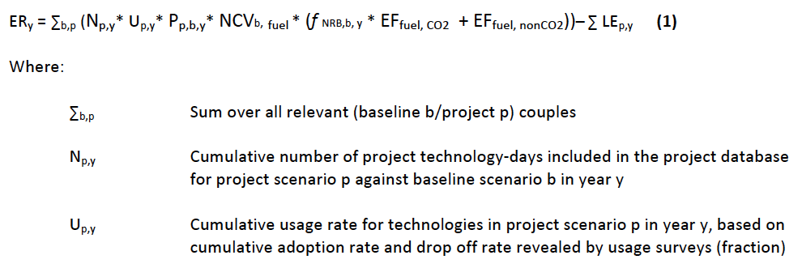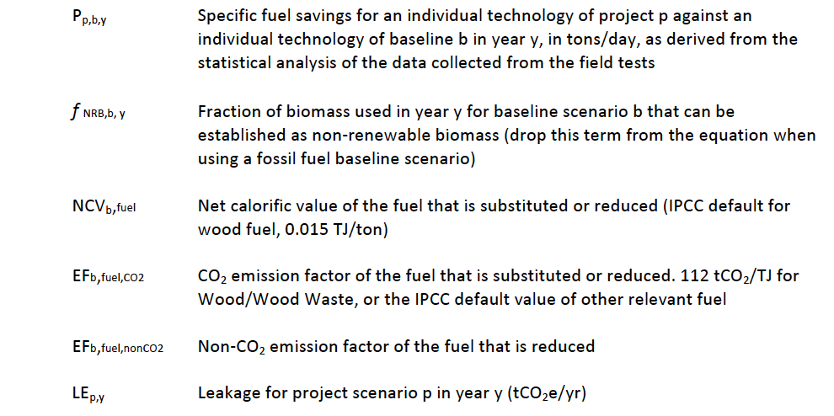

SDG Goal | Baseline Situation | Expected impact
1 – No Poverty | Dollars spent purchasing fuelwood:  US$ 5 per week per household. | Reduction of 25% US Dollars saved purchasing fuelwood. US$ 3 saved per week per HH.
1 – No Poverty | Time spent collecting fuelwood: 3.29 Hours/week | Time saved collecting fuelwood: 2.02 Hours/week (a reduction of 56%)
1 – No Poverty | Fuel consumption in baseline stove: 0.013130 t/household/day | Savings in fuelwood consumption: 0.004840 t/household/day
2 – Zero Hunger | Dollars spent purchasing fuelwood: US$ 5 per week per HH. | Reduction of 50% US Dollars saved purchasing fuelwood. US$ 2.15 per week per HH.
2 – Zero Hunger | 0% of people reporting they used money saved purchasing fuelwood to buy food. The time and money dedicated to buy firewood, in many cases, prevents people from buying food. | 50% of people reporting they used money saved purchasing fuelwood to buy food
3 – Good Health and Well-Being | Mean PM2.5 exposure using the traditional fogon: 221 μg/m3. | 47% reduction in personal exposure to PM2.5 (The exposure to PM2.5 is reduced from 221 μg/m3 to 117 μg/m3)
3 – Good Health and Well-Being | The soot and ashes inside the homes when using the traditional fogon affect the cleanliness. The black walls and ceiling prevent people from experiencing a clean and neat space. | 99% people reporting the air inside their homes is cleaner after installation of the improved cookstove
3 – Good Health and Well-Being | Time spent collecting fuelwood: 3.29 hours/week | Time saved collecting fuelwood:  2.02 hours/week (a reduction of 56%)
3 – Good Health and Well-Being | Dollars spent purchasing fuelwood:  US$ 5 per week per HH. | Money saved purchasing fuelwood:  US$ 3 per week per HH (a reduction of 25%).
4 – Quality Education | 0 Hours Training provided per year. In absence of the project the job positions would not exist; therefore, no training is offered to the project personnel. | 346 training hours provided per year
5 – Gender Equality | In absence of the project the job positions would not exist; therefore, there is no employment generated. | Employment records showing the proportion of women employed by job type: 31% (direct employees);  22% (overall, including all field personnel)
5 – Gender Equality | The traditional fogon allows the user to cook only one dish at time, which demands more time for that task. | 96% Qualitative surveys to determine if the Dos por Tres cooks faster (e.g., more than one cooking pot can be used simultaneously along with tortillas).
5 – Gender Equality | Cooking with the traditional fogon is a burden due to the smoke, soot and ashes; it is also time consuming. | The project will test the level of satisfaction of the Dos por Tres stove by asking if there is anything users don't like about the Dos por Tres: 1% of users say there is something they don’t like about the stove.
5 – Gender Equality | Family budget is typically managed by the male spouse. Having a home improvement in the kitchen can be prevented if the Dos por Tres would represent an expediture. | 3,400 stoves built per year.
7 – Affordable and Clean Energy | Fuel consumption in baseline stove 0.013130 t/household/day | Savings in fuelwood consumption: 0.004840 t/household/day
7 – Affordable and Clean Energy | No NRB assessment by the project.  PM 2.5 release 17,631(mg) in the traditional fogon | Assessment of fNRB: Guatemala 79.28 %  79% reduction in release of PM2.5 (mg, 3,658)
8 – Decent Work and Economic Growth | In absence of the project the job positions would not exist; therefore, no direct and indirect employment reporting is done. | Results of qualitative annual survey to employees: 95% show job satisfaction
8 – Decent Work and Economic Growth |  | Quantitative employment:  - Direct Employees, Honduras (main office): 25  - Direct Employees, USA: 4  - Ejecutores and Technicians: 14  - Suppliers (Nicaragua): 9  - Indirect Employees, USA: 3  - GRAND TOTAL: 55
15 – Life on Land | Fuel consumption in baseline stove: 0.013130 t/household/day | Savings infirewood, 0.004840 t/household/day
15 – Life on Land | See SDG 13 below | See SDG 13 below
13 - Climate Action | Lab and field testing of baseline and project scenario stove types to quantify the reduction of Carbon Dioxide and other harmful GHGs. | Total Emissions Reductions, first crediting period: 81,348 tCO₂e  Yearly average 16,270 tCO₂e.

Net benefit, Yearly average of emission reductions: 16,270 tCO2e
 |  | Baseline | Project | Net
Ex-ante ERs per year (tCO2e) | Year 1 | 3,027 | 1,909 | 1,093
Ex-ante ERs per year (tCO2e) | Year 2 | 12,158 | 7,676 | 4,421
Ex-ante ERs per year (tCO2e) | Year 3 | 40,411 | 25,514 | 14,769
Ex-ante ERs per year (tCO2e) | Year 4 | 69,508 | 43,887 | 25,502
Ex-ante ERs per year (tCO2e) | Year 5 | 96,801 | 61,119 | 35,563
Total |  | 221,905 | 140,105 | 81,348
Yearly average |  | 44,381 | 28,021 | 16,270

      - Data and parameters fixed ex ante for monitoring contribution to each of the three SDGs
(Include a compilation of information on the data and parameters that are not monitored during the crediting period but are determined before the design certification and remain fixed throughout the crediting period like IPCC defaults and other methodology defaults. Copy this table for each piece of data and parameter.)
Relevant SDG Indicator | 13 – Climate Action  • 13.1.1 Number of deaths, missing persons and directly affected  persons attributed to disasters per 100,000 population
Data/parameter | ID 1 / EFfuel,CO2
Unit | tCO2/TJ
Description | CO2 emission factor of the fuel that is reduced
Source of data | 2006 IPCC Guidelines for National Greenhouse Gas Inventories 2.1,  Volume 2: Energy  (https://www.ipcc-nggip.iges.or.jp/public/2006gl/pdf/  2_Volume2/V2_2_Ch2_Stationary_Combustion.pdf)
Value(s) applied | 112 tCO2/TJ
Choice of data or Measurement methods and procedures | IPCC default value
Purpose of data | Calculation of baseline and project emissions
Additional comment

Relevant SDG Indicator | 13 – Climate Action  • 13.1.1 Number of deaths, missing persons and directly affected  persons attributed to disasters per 100,000 population
Data/parameter | ID 2 / EF_{fuel,nonCO2,CH4}
Unit | tCO2/TJ
Description | CH4 emission factor for the fuel that is reduced
Source of data | 2006 IPCC Guidelines for National Greenhouse Gas Inventories 2.1,  Volume 2: Energy  (https://www.ipcc-nggip.iges.or.jp/public/2006gl/pdf/  2_Volume2/V2_2_Ch2_Stationary_Combustion.pdf)
Value(s) applied | 0.30
Choice of data or Measurement methods and procedures | IPCC default value
Purpose of data | Calculation of baseline and project emissions
Additional comment

Relevant SDG Indicator | 13 – Climate Action  • 13.1.1 Number of deaths, missing persons and directly affected  persons attributed to disasters per 100,000 population
Data/parameter | ID 3 / EF_{fuel,nonCO2,N2O}
Unit | tCO2e/TJ
Description | N2O emission factor for wood that is reduced
Source of data | IPCC Default value
Value(s) applied | 0.004
Choice of data or Measurement methods and procedures | 2006 IPCC Guidelines for National Greenhouse Gas Inventories 2.1,  Volume 2: Energy  (https://www.ipcc-nggip.iges.or.jp/public/2006gl/pdf/  2_Volume2/V2_2_Ch2_Stationary_Combustion.pdf)
Purpose of data | Calculation of baseline and project emissions
Additional comment

Relevant SDG Indicator | 13 – Climate Action  • 13.1.1 Number of deaths, missing persons and directly affected  persons attributed to disasters per 100,000 population
Data/parameter | ID 4 / NCVfuel
Unit | TJ/ton
Description | The Net Calorific Value (NCV) of the fuel that is substituted or reduced
Source of data | IPCC default for wood fuel
Value(s) applied | 0.015 TJ/ton
Choice of data or Measurement methods and procedures | NCV for wood fuel
Purpose of data | Calculation of baseline and project emissions
Additional comment

Relevant SDG Indicator | 15 – Life on Land  • 15.2.1 By 2020, promote the implementation of sustainable  management of all types of forests, halt deforestation, restore  degraded forests and substantially increase afforestation and  reforestation
Data/parameter | ID 5 / fNRB,b,y
Unit | %
Description | The non-renewable fraction of the woody biomass harvested in the project  collection area in year y in the baseline scenario
Source of data | fNRB Calculation Guatemala V3 13 Feb 2021 CONFIDENTIAL Comparison GS UPDATED.xls
Value(s) applied | 79.28
Choice of data or Measurement methods and procedures | Technologies and Practices to Displace Decentralized Thermal Energy Consumption” (TPDDTEC) version 2.0
Purpose of data | Calculation of project emissions.
Additional comment

      - Ex ante estimation of outcomes linked to each of the three SDGs
>> (Provide a transparent ex ante calculation of baseline and project outcomes (or, where applicable, direct calculation of net benefit) during the crediting period, applying all relevant equations provided in the selected methodology(ies) or as per proposed approach. For data or parameters available before design certification, use values contained in the table in section B.6.3 above. For data/parameters not available before design certification and monitored during the crediting period, use estimates contained in the table in section B.7.1 below)

Ex ante calculations related to the outcomes of SDG 13, SDG15
A detailed ex-ante calculation of the outcome for SDG 13 and SDG15 is provided in a separate excel file (uploaded to SustainCert App). For data/parameters available before design certification values contained in section B.6.3 and for data/parameters not available before design certification the estimates contained in section B.7.1 have been used.

Ex ante calculations related to the outcomes of SDG1, SDG2, SDG3, SDG4, SDG5, SDG7, SDG8,
The impact monitoring relating to those SDGs is also made through a qualitative evaluation of the sample families during the annual Usage Survey, Kitchen Performance Test, and project management data as described above in section B.6.2.

      - Summary of ex ante estimates of each SDG outcome

The ex-ante estimation of Baseline and Project emissions are based on data available from VPA1. The KPTs’ results will be available on time the verification.
Year | Baseline estimate (tCO2eq) | Project estimate (tCO2eq) | Net benefit (tCO2eq)
Year 1 | 3,027 | 1,909 | 1,093
Year 2 | 12,158 | 7,676 | 4,421
Year 3 | 40,411 | 25,514 | 14,769
Year 4 | 69,508 | 43,887 | 25,502
Year 5 | 96,801 | 61,119 | 35,563
Total | 3,027 | 1,909 | 1,093
Total number of crediting years | 5 | 5 | 5
Annual average over the crediting period (tCO2eq) | 44,381 | 28,021 | 16,270
    - Monitoring plan
      - D ata and parameters to be monitored
(Include specific information on how the data and parameters that need to be monitored in the selected methodology(ies) or proposed approaches or as per mitigation measures from safeguarding principles assessment or as per feedback from stakeholder consultations would actually be collected during monitoring. Copy this table for each piece of data and parameter.)
Relevant SDG Indicator | 13 – Climate Action  • 13.1.1 Number of deaths, missing persons and directly affected  persons attributed to disasters per 100,000 population
Data / Parameter | ID 6 / Np,y
Unit | Number of project technology days
Description | Cumulative number of project technology-days included in the project  database for project scenario p against baseline scenario b in year y
Source of data | Salesforce.com installation database (estimated values based on the stove installation forecast, see ´Ex-Ante ER Calculations VPA2 Guatemala 09 Jul 2020’
Value(s) applied | 461,002
Measurement methods and procedures | Stoves are built in situ and a unique household account is created in the  electronic database at the time of construction. Data integrity is checked and maintained by the Director of Technology in Honduras on an ongoing basis. Throughout the process by which data is gathered and verified in the field, the office team, under the supervision of the Director of Technology, cross checks and reviews the data with various data deduplication tools, checking the data for quality, eliminating duplicates if found, and making sure that the required data is being captured on all records. The electronic database is automatically backed up. If any data is modified or changed, a record history is tracked. The Salesforce.com database holds the following information to identify each household using project technology:  - Installation record  - Date of installation  - Location of installation  - Model/type of stove installed  - Model of use prior to installation of project stove  - Name of beneficiary
Monitoring frequency | Continually, reported annually
QA/QC procedures | As per CME Management System
Purpose of data | Calculation of emission reductions
Additional comment | With reference to SDG 5: Mirador’s no-cash model puts decision power  in the hands of women by not requiring they use family income, which  may require approval of a spouse.  With reference to SDG 16: Mirador’s no-cash model reduces the risk that any form of corruption or bribery will be employed at any point during the stove process.  This parameter is replicated in Section D.7.1 of the VPA-DD for VPA1 (see p. 25, ID6).  Cross-reference to GS v2.2 documentation: ID 6 – Np,y

Relevant SDG Indicator | 15 – Life on Land  • 15.2.1 By 2020, promote the implementation of sustainable  management of all types of forests, halt deforestation, restore degraded forests and substantially increase afforestation and reforestation
Data / Parameter | ID 7 / Pp,b,y
Unit | tonnes/household/day
Description | Average daily dry wood fuel reduction per person-meal (Specific fuel  savings from an individual technology of project p against an individual  technology of baseline b in year y)
Source of data | Kitchen Performance Test and associated third-party KPT data analysis (value based on Weighted Average Fuel Savings from VPA1)
Value(s) applied | 0.004840
Measurement methods and procedures | Monitor baseline and project scenario fuelwood consumption through 4-day Kitchen Performance Tests (KPTs) for each age group of stoves  included, aggregating new data annually.
Monitoring frequency | Bi-annual
QA/QC procedures | As per CME Management System.
Purpose of data | Assess sustainability; calculate emission reductions
Additional comment | This parameter is replicated in Section D.7.1 of the VPA-DD for VPA1 (see p. 26, ID 7).  Cross-reference to GS v2.2 documentation:  ID7 – Pp,b,y

Relevant SDG Indicator | 13 – Climate Action  • 13.1.1 Number of deaths, missing persons and directly affected  persons attributed to disasters per 100,000 population
Data / Parameter | ID 8 / Up,y
Unit | % of households
Description | Abandonment (drop-off) rate (the number of stoves that have fallen out  of use in a given age group)
Source of data | Survey and visual observation (Values from latest monitoring report of VPA1 see (estimated values based on the stove installation forecast, see ´Ex-Ante ER Calculations VPA2 Guatemala 09 Mar 2021)
Value(s) applied
  Abandonment Assumption | VP9 | Monitored
  Abandonment Assumption | Applied | (Cumulative)
  Age 0-1 | 4% | 4%
  Age 1-2 | 3% | 6%
  Age 2-3 | 7% | 14%
  Age 3-4 | 1% | 15%
  Age 4-5 | 18% | 33%
  Age 5-6 | 21% | 54%
Measurement methods and procedures | Surveys compiled by handheld device and uploaded to Salesforce.com  database.
Monitoring frequency | Continually, reported annually
QA/QC procedures | As per CME Management System
Purpose of data | Calculate emission reductions
Additional comment | Estimated values based on latest Verification period No. 10th

Relevant SDG Indicator | 13 – Climate Action  • 13.1.1 Number of deaths, missing persons and directly affected  persons attributed to disasters per 100,000 population
Data / Parameter | ID 9 / LEp,y
Unit | tCO₂e
Description | Assess leakage sources including (1) replacement of efficient household  heating sources with less efficient fuel; (2) continued use of baseline stove after installation; (3) double counting
Source of data | Ongoing questionnaires (Values from latest monitoring report of VPA1 (estimated values based on the stove installation forecast, see ´Ex-Ante ER Calculations VPA2 Guatemala 09 Mar 2021)
Value(s) applied | Year 1: 25  Year 2: 61  Year 3: 128  Year 4: 119  Year 5: 119
Measurement methods and procedures | Survey, on an ongoing basis, 1 of every 100 new Dos por Tres stove  owners. Questionnaires to be administered by Mirador Supervisors and  data kept in Salesforce.com database.
Monitoring frequency | Annually
QA/QC procedures | As per CME Management System
Purpose of data | Calculation of leakage
Additional comment | Estimated values based on latest Verification period No. 10th

Relevant SDG Indicator | 13 – Climate Action  • 13.1.1 Number of deaths, missing persons and directly affected  persons attributed to disasters per 100,000 population
Data / Parameter | ID 10 / LEp,y – Leakage due to Transportation
Unit | %
Description | Assess leakage due to transportation
Source of data | Mileage records; transportation and maintenance records (based on the last monitoring report figure for Leakage due to Transportation, which is calculated as 0.05% of the total emissions claimed, so it is disregarded as de minimis.)
Value(s) applied | 0.0%
Measurement methods and procedures | Vehicle odometer checks at each instance of reporting, compiled and  tabulated by support staff in central office.
Monitoring frequency | Calculate emission reductions
QA/QC procedures | Annually
Purpose of data | As per CME Management System
Additional comment | It should also be noted that due to the reduction in fuelwood use, the  project is expected to result in reduced leakage emissions due to the  reduced need for transportation of fuel.

Relevant SDG Indicator | 7 – Affordable and Clean Energy  • 7.3.1 Energy intensity measured in terms of primary energy and  GDP
Data / Parameter | ID 11 / % reduction in release of PM2.5
Unit | %
Description | Measurement of the reduction of PM2.5 emissions resulting from  cookstove intervention.
Source of data | McCarty, Nordica & Still, Dean, “Results of Testing the Overlook  Foundation Justa Stoves Including the ‘2 x 3’ Stove: Fuel Use and  Carbon/CO₂eq Savings” (2009)
Value(s) applied | 79%
Measurement methods and procedures | The Water Boiling Test (WBT) was used to determine relative PM2.5  emissions in the baseline vs. project stove, as measured by Aprovecho’s  Research Center’s commercially available Portable Emissions  Measurement System (PEMS), in which real-time emissions of carbon  dioxide (CO₂), carbon monoxide (CO) and particulate matter (PMTSP)  are recorded.
Monitoring frequency | Annually
QA/QC procedures | As per CME Management System
Purpose of data | Assess sustainability
Additional comment | Due to the cost and complexity of such studies, PP will maintain original monitored figures unless it is determined that baseline or project conditions have materially changed or testing methodologies require reassessment.

Relevant SDG Indicator | 3 – Good Health and Well Being  • 3.9.1 Mortality rate attributed to household and ambient air  pollution
Data / Parameter | ID 12 / % reduction in personal exposure to PM2.5
Unit | %
Description | Measurement of the reduction of personal exposure to PM2.5 (as  opposed to the overall reduction to PM2.5) resulting from cookstove  intervention.
Source of data | Lefebvre, Olivier, “Health Impact of Proyecto Mirador 2x3 Stove” (2018)
Value(s) applied | 47%
Measurement methods and procedures | Exposure to PM2.5 was measured in real-life control and intervention  households using a the HAPEx Nano light scattering nephelometer. This device provides real time readings on PM2.5 and takes a new  measurement every minute. It was worn by study participants in control  and intervention groups during a 48-hour period.
Monitoring frequency | Annually
QA/QC procedures | As per CME Management System.
Purpose of data | Assess sustainability
Additional comment | Due to the cost and complexity of such studies, PP will maintain original monitored figures unless it is determined that baseline or project conditions have materially changed or testing methodologies require reassessment.

Relevant SDG Indicator | 1 – No Poverty  • 1.2.2 Proportion of men, women and children of all ages living in  poverty in all its dimensions according to national definitions
Data / Parameter | ID 13 / Time saved collecting fuelwood
Unit | Hours/week
Description | For clients who collect their own wood, PP will monitor how much time  they have saved, and how they invest the time saved.
Source of data | Responses to qualitative surveys (Based on results from Leakage and Sustainability Surveys collected by Mirador supervisors in the 10th verification)
Value(s) applied | 2.02 (a reduction of 56%)
Measurement methods and procedures | Using smartphone devices, Supervisors collect surveys which are stored  and reported in a Salesforce.com database. Randomness of sample  maintained by surveying every nth client who receives a supervisory visit  from Mirador.
Monitoring frequency | Annually
QA/QC procedures | As per CME Management System
Purpose of data | Assess sustainability
Additional comment | Cross-reference to GS v2.2 documentation:  ID 12 – Livelihood of the poor; ID 13 – Human & Institutional Capacity

Relevant SDG Indicator | 1 – No Poverty  • 1.2.2 Proportion of men, women and children of all ages living in  poverty in all its dimensions according to national definitions
Data / Parameter | ID 14 / US dollar saved purchasing fuelwood
Unit | US Dollars
Description | For clients who purchase fuelwood, PP will monitor how much money  clients save due to the reduction in fuelwood consumption and track how  the saved funds are spent.
Source of data | Responses to qualitative surveys (Based on results from Leakage and Sustainability Surveys collected by Mirador supervisors in the 10th verification)
Value(s) applied | US$ 3 (per week per HH, a reduction of 25%)
Measurement methods and procedures | Using smartphone devices, Supervisors collect surveys which are stored  and reported in a Salesforce.com database. Randomness of sample  maintained by surveying every nth client who receives a supervisory visit  from Mirador.
Monitoring frequency | Annually
QA/QC procedures | As per CME Management System
Purpose of data | Assess sustainability
Additional comment | Cross-reference to GS v2.2 documentation:  ID 12 – Livelihood of the poor; ID 13 – Human & Institutional Capacity

Relevant SDG Indicator | 2 – Zero Hunger  • 2.1.1 Prevalence of undernourishment
Data / Parameter | ID 15 / % of people reporting they used US dollar saved purchasing  fuelwood to buy food
Unit | %
Description | For clients who report saving money due to the reduction in fuelwood  purchased, PP will monitor how the saved funds are spent.
Source of data | Responses to qualitative surveys (Based on results from Leakage and Sustainability Surveys collected by Mirador supervisors in the 10th verification)
Value(s) applied | 50%
Measurement methods and procedures | Using smartphone devices, Supervisors collect surveys which are stored  and reported in a Salesforce.com database. Randomness of sample  maintained by surveying every nth client who receives a supervisory visit  from Mirador.
Monitoring frequency | Annually
QA/QC procedures | As per CME Management System.
Purpose of data | Assess sustainability
Additional comment | See SDG 1 – No Poverty (parameters ID 13 and ID 14) for qualitative data showing savings of time and money. While direct monetary savings is the monitored parameter for SDG 2, it should be noted that time savings (for those who collect their fuelwood) can also translate to higher income, if saved time is dedicated to work that generates income.  Cross-reference to GS v2.2 documentation:  ID 12 – Livelihood of the poor; ID 13 – Human & Institutional Capacity

Relevant SDG Indicator | 3 – Good Health and Well Being  • 3.9.1 Mortality rate attributed to household and ambient air  pollution
Data / Parameter | ID 16 / % of households that report the air inside the home is cleaner
Unit | %
Description | Households are surveyed to determine if they report the air is cleaner after installation of the Mirador stove.
Source of data | Responses to qualitative surveys (Based on results from Leakage and Sustainability Surveys collected by Mirador supervisors in the 10th verification)
Value(s) applied | 99%
Measurement methods and procedures | Using smartphone devices, Supervisors collect surveys which are stored  and reported in a Salesforce.com database. Randomness of sample  maintained by surveying every nth client who receives a supervisory visit  from Mirador.
Monitoring frequency | Annually
QA/QC procedures | As per CME Management System
Purpose of data | Assess sustainability
Additional comment | Cross-reference to GS v2.2 documentation:  ID 11 – Air Quality

Relevant SDG Indicator | 4 – Quality Education  • 4.3.1 Participation rate of youth and adults in formal and nonformal  education and training in the previous 12 months, by sex
Data / Parameter | ID 17 / Training hours provided per year
Unit | Hours/year
Description | Demonstrate the transfer of useful and marketable job skills to local direct  and indirect employees through training records.
Source of data | Human resource training records (Based on results from Leakage and Sustainability Surveys collected by Mirador supervisors in the 10th verification)
Value(s) applied | 346 Hours
Measurement methods and procedures | Human resources specialist tracks all hours spent by Mirador employees  and associates in various types of training and/or certification programs.
Monitoring frequency | Annually
QA/QC procedures | As per CME Management System.
Purpose of data | Assess sustainability
Additional comment | Cross-reference to GS v2.2 documentation:  ID 16 – Technology Transfer

Relevant SDG Indicator | 5 – Gender Equality  • 5.5.2 Proportion of women in managerial positions
Data / Parameter | ID 18 / Proportion of employees who are women
Unit | %
Description | Employment records showing the proportion of women employed, by job type
Source of data | Human resources specialist (Based on results from Leakage and Sustainability Surveys collected by Mirador supervisors in the 10th verification)
Value(s) applied | 31% (direct employees)  22% (overall, including all field personnel).
Measurement methods and procedures | Human resources specialist tracks all hours spent by Mirador employees  and associates in various types of training and/or certification programs.
Monitoring frequency | Annually
QA/QC procedures | As per CME Management System.
Purpose of data | Assess sustainability
Additional comment | While the gender balance of Mirador’s managerial and office positions is rather even, despite sincere efforts it is extremely difficult to find women who are willing to fill stove construction jobs—partly because it is physically very taxing, but especially because it involves long periods of time away from home and family. We are continually striving to find ways to creatively address this issue.  Cross-reference to GS v2.2 documentation:  ID 15 – Quantitative Employment and Income Generation

Relevant SDG Indicator | 5 – Gender Equality  • 5.c.1 Proportion of countries with systems to track and make public  allocations for gender equality and women’s empowerment
Data / Parameter | ID 19 / Improvemet in cooking time
Unit | %
Description | Qualitative surveys to determine if the 2x3 cooks faster, slower or the same
Source of data | Responses to qualitative surveys (Based on results from Leakage and Sustainability Surveys collected by Mirador supervisors in the 10th verification)
Value(s) applied | 96% (% of respondents that say the Dos por Tres cooks faster)
Measurement methods and procedures | Surveys are taken onsite via handheld device and tracked using Salesforce.com database
Monitoring frequency | Annually
QA/QC procedures | As per CME Management System
Purpose of data | Assess sustainability
Additional comment | Reduced time spent cooking allows women to have more discretionary  time that they can spend as they wish, rather than doing the cooking  task assigned to them.  Usage monitoring with SUMS devices in 2018 confirmed that the average cooking event performed on the 2x3 was 11% shorter (20 minutes) than the average cooking event performed on the traditional fogón.

Relevant SDG Indicator | 5 – Gender Equality  • 5.c.1 Proportion of countries with systems to track and make public  allocations for gender equality and women’s empowerment
Data / Parameter | ID 20 / % of users who say there is something they don’t like about  the stove
Unit | %
Description | Qualitative surveys to show how much cooking time is reduced after  installation of ICS
Source of data | Responses to qualitative surveys (Based on results from Leakage and Sustainability Surveys collected by Mirador supervisors in the 10th verification)
Value(s) applied | 1%
Measurement methods and procedures | Human resources specialist tracks all hours spent by Mirador employees  and associates in various types of training and/or certification programs.
Monitoring frequency | Annually
QA/QC procedures | As per CME Management System
Purpose of data | Assess sustainability
Additional comment | Women in Central America spend a large part of their time cooking.  Mirador eases their burden by providing a stove that functions to their  satisfaction.

Relevant SDG Indicator | 8 – Decent Work and Economic Growth  • 8.8.2 Level of national compliance with labour rights (freedom of  association and collective bargaining) based on International Labour  Organization (ILO) textual sources and national legislation, by sex  and migrant status
Data / Parameter | ID 21 / % of Mirador employees and microenterprises who report  they are satisfied with their jobs
Unit | %
Description | Results of qualitative annual survey to employees showing job satisfaction
Source of data | Human resources specialist (Online survey administered by Director of Human Resources, values based on results from survey carried out in the 10th verification of VPA1)
Value(s) applied | 95%
Measurement methods and procedures | Annual qualitative survey administered electronically or on paper, and  tabulated electronically.
Monitoring frequency | Annually
QA/QC procedures | As per CME Management System
Purpose of data | Assess sustainability
Additional comment | Cross-reference to GS v2.2 documentation:  ID 14 – Quality of Employment

Relevant SDG Indicator | 8 – Decent Work and Economic Growth  • 8.5.2 Unemployment rate, by sex, age and persons with disabilities
Data / Parameter | ID 22 / Quantitative employment by job type
Unit | Number of employees
Description | Employment records showing the number of people employed by the  project (direct and indirect)
Source of data | Human resources specialist (Online survey administered by Director of Human Resources, values based on results from survey carried out in the 10th verification of VPA1)
Value(s) applied | Quantitative employment:  o Direct Employees Honduras (main office) 25  o Direct Employees USA 4  o Executors and Technicians 14  o Suppliers (Nicaragua) 9  o Indirect Employees USA 3  o GRAND TOTAL 55
Measurement methods and procedures | Annual qualitative survey administered electronically or on paper, and  tabulated electronically.
Monitoring frequency | Annually
QA/QC procedures | As per CME Management System
Purpose of data | Assess sustainability
Additional comment | Cross-reference to GS v2.2 documentation:  ID 15 – Quantitative Employment and Income Generation

Relevant SDG Indicator | 13 – Climate Action  • 13.1.1 Number of deaths, missing persons and directly affected  persons attributed to disasters per 100,000 population
Data / Parameter | ID 23 / Tonnes of CO2 reduced
Unit | mtCO2e
Description | Number of tonnes of CO2 reduced in a given monitoring period
Source of data | Monitoring report (Value applied based on the annual average of the ex-ante emission reductions calculations)
Value(s) applied
  Year | Emission reductions (tCO2eq)
  Year 1 | 1,093
  Year 2 | 4,421
  Year 3 | 14,769
  Year 4 | 25,502
  Year 5 | 35,563
  Total | 81,348
  Total number of crediting years | 5
  Annual average over the crediting period (tCO2eq) | 16,270
Measurement methods and procedures | Calculate VERs per the following equation:  ERy = Σb,p (N_{p,y} * U_{p,y} * P_{p,b,y} * NCV_{b,fuel} * (f_{NRB,b,y} * EF_{fuel,CO2} + EF_{fuel,nonCO2})) – Σ LE_{p,y} (1)
Monitoring frequency | Annually
QA/QC procedures | As per CME Management System
Purpose of data | Assess sustainability
Additional comment

Relevant SDG Indicator | 3 – Good Health and Well Being  • 3.9.1 Mortality rate attributed to household and ambient air  pollution
Data / Parameter | ID 24 / % people perceiving cleaner air inside their homes after the installation of the improved cookstove.
Unit | %
Description | Qualitiative surveys to determine if people perceive the air inside their homes is cleaner after installation of the improved cookstove
Source of data | Lefebvre, Olivier, “Health Impact of Proyecto Mirador 2x3 Stove” (2018)
Value(s) applied | 99%
Measurement methods and procedures | Exposure to PM2.5 was measured in real-life control and intervention  households using a the HAPEx Nano light scattering nephelometer. This device provides real time readings on PM2.5 and takes a new  measurement every minute. It was worn by study participants in control  and intervention groups during a 48-hour period.
Monitoring frequency | Annually
QA/QC procedures | As per CME Management System.
Purpose of data | Assess sustainability
Additional comment | Due to the cost and complexity of such studies, PP will maintain original monitored figures unless it is determined that baseline or project conditions have materially changed or testing methodologies require reassessment.

Moniotring approach for SDGs
SDG Goal | Monitoring approach:
1 – No Poverty | • For clients who purchase fuelwood, PP will gather qualitative surveys to monitor how much money clients save due to the reduction in fuelwood consumption and track how the saved funds are spent.
1 – No Poverty | • For clients who collect their own wood, PP will monitor how much time they have saved, and how they invest their time (which often includes more time dedicated to work).
1 – No Poverty | • Monitor baseline and project scenario fuelwood consumption through 4-day Kitchen Performance Tests (KPTs) for each age group of stoves included, aggregating new data annually.
2 – Zero Hunger | • For clients who purchase fuelwood, PP will gather qualitative surveys to monitor how much money clients save due to the reduction in fuelwood consumption and track how the saved funds are spent. For many families, this includes purchasing food.
2 – Zero Hunger | • For clients who collect their own wood, PP will monitor how much time they have saved, and how they invest their time, which often includes more time dedicated to work. More time to work translates to higher income which mobilizes funds for purchasing food.
3 – Good Health and Well-Being | • Lab and field testing of baseline and project scenario stove types to quantify the reduction of harmful indoor pollution emissions of PM 2.5 and Carbon Monoxide (measurements include both ambient emissions and personal exposure, based on results of previous tests done)
3 – Good Health and Well-Being | • Qualitiative surveys to determine if people perceive the air inside their homes is cleaner after installation of the improved cookstove.
3 – Good Health and Well-Being | • Qualitative surveys to indicate that time spent collecting wood is reduced.
3 – Good Health and Well-Being | • Qualitative surveys to indicate that money spent purchasing wood is reduced.
4 – Quality Education | • Maintain detailed training records for all training provided to staff, contractors and technicians.
5 – Gender Equality | • Maintain records showing quantitative employment generated by the project, including a breakdown of the gender balance by job type.
5 – Gender Equality | • Show that the stove provides women with more discretionary time by presenting the % time saved by using the Dos por Tres.  • Provide data to show that women are satisfied with their cookstove, thus easing their burden of difficulty.
5 – Gender Equality | • Show that the project collects feedback and impressions to demonstrate the level of satisfaction with the stove.
5 – Gender Equality | • Document the number of stoves built, keeping in mind that Mirador’s no-cash model enables women to receive a stove without having to ask for a spouse’s approval to spend household money—thus placing decision making power in the woman’s hands.
7 – Affordable and Clean Energy | • Monitor baseline and project scenario fuelwood consumption through 4-day Kitchen Performance Tests (KPTs) for each age group of stoves included, aggregating new data annually.
7 – Affordable and Clean Energy | • Assess the non-renewable fraction of the woody biomass harvested in the project collection area.  • Measurement of the reduction of PM2.5 emissions resulting from  cookstove intervention.
8 – Decent Work and Economic Growth | • For the figure “% of Mirador employees and microenterprises who report they are satisfied with their jobs”, only Mirador project employees are surveyed. Thus, baseline value calculation is inapplicable.
8 – Decent Work and Economic Growth | • Maintain records showing quantitative employment generated by the project, including Mirador’s direct employees and all related microenterprises.
8 – Decent Work and Economic Growth | • Conduct employee surveys to assess job satisfaction and confirm alignment with work regulations.
15 – Life on Land | • Monitor baseline and project scenario fuelwood consumption through 4-day Kitchen Performance Tests (KPTs) for each age group of stoves included, aggregating new data annually. A reduction in fuelwood consumption indicates mitigation of forest degradation.
15 – Life on Land | • Document and report reduction of GHGs through annual reporting of emission reduction calculations.
13 - Climate Action | • Lab and field testing of baseline and project scenario stove types to quantify the reduction of Carbon Dioxide and other harmful GHGs.

Following the methodology requirements, below there are details of the leakage assessment:
Potential source of leakage | Assessment
a) The displaced baseline technologies are reused outside the project boundary in place of lower emitting technology or in a manner suggesting more usage than would have occurred in the absence of the project. | The baseline stoves are not used outside the project boundary, but in some cases, the stove continue being used by the project beneficiaries. Anyway, the project account for leakage due to the continued presence of a baseline stove.  Although one of the requirements for the beneficiaries to join the project is to destroy the baseline stove, because some beneficiaries refuse to destroy the stove and the construction of an open fire is extremely easy, (e.g it only requires three cinder block or bricks.) the presence of a baseline stove will be monitored via the annual monitoring surveys.  This leakage source is calculated as follows:  Leakage due baselines stove = % of homes that have a fogón * net  stoves in operation * cooking time the fogón is in use in those HHs * annualized  average of ERs/stove  This approach has been approved by GS in previous verification of the VPA1
b) Non‐project users who previously used lower emitting energy sources use the non‐renewable biomass or fossil fuels saved under the project activity. | There is no such distinction between a low emitting energy and non-renewable biomass from the firewood consumed in project area. Areas of fuelwood collection, fuelwood suppliers and fuel type are the same for both, project users and non-project users. This potential source of leakage is not considered relevant for the project.
c) The project significantly impacts the NRB fraction within an area where other CDM or VER project activities account for NRB fraction in their baseline scenario. | The project does not expect to create a negative impact on the NRB; if any, the impact would be positive since the project saves fuelwood reducing the demand. This potential source of leakage is not considered relevant for the project.
d) The project population compensates for loss of the space heating effect of inefficient technology by adopting some other form of heating or by retaining some use of inefficient technology. | The project will carry out an annual survey to assess the leakage due to the replacement of efficient household heating. The project users will be asked if they use their Dos por Tres to heat the home outside of regular cooking activity.  For the past verification completed for the VPA1, this source of leakage was determined to be zero.
e) By virtue of promotion and marketing of a new technology with high efficiency, the project stimulates substitution within households who commonly used a technology with relatively lower emissions, in cases where such a trend is not eligible as an evolving baseline. | One of the requirements for the beneficiaries to join the project is to use firewood as main fuel for cooking. Users of technology with relatively lower emissions are not eligible.
Other potential sources of leakage.  Double counting was determined as follows  Leakage due to Transportation. | This source of leakage happens when the presence of another ICS is found in project households. This source of leakage will be determined as follows:  Leakage due to double counting =  (total number of HHs surveyed for the presence of another ICS ÷ total number of HHs surveyed in which another ICS was present ) * net stoves in operation * annualized average of ERs/stove  This approach has been approved by GS in previous verifications of VPA1.  Transportation and maintenance records will be maintained. Records include all vehicle types in use by the project at all levels (large trucks, light trucks and motorcycles). Mileage records track miles driven on an ongoing basis for each vehicle, and the results are tabulated annually. A standard online carbon calculator is used to calculate the total CO2 produced from driving the total distance driven. That figure is compared against the total emissions being claimed during the verification period in order to determine leakage.  In all verifications completed thus for for VPA1, leakage due to transportation was determined to be less than 0.1% of the total ERs (de minimis).  This approach has been approved by GS in previous verifications of VPA1.

      - Sampling plan
>> (If data and parameters monitored in section B.7.1 above are to be determined by a sampling approach, provide a description of the sampling plan.)

For the KPTs the sample size will be aligned with a COV (typically in the range of 0.5-1.0), no less than 30 samples. In the case of a pair, the 90/30 sample rule will be met. If a single sample approach is applied, the 90/10 rule as per the methodology will be applied.

Based on the KPT results (to be ready on time of the verification), the CME will decide whether to apply the cross sampling or a sampling group for each VPA. In any case, the CME will meet the relevant precision/confidence level.

      - Other elements of monitoring plan
>>
The sampling plan follows the requirements stated in the methodology applied (TPDDTEC v2.0), which are summarized below:

For the usage surveys (to be completed annually) the minimum total sample size is 100, with at least 30 samples for project technologies of each age being credited. To ensure conservativeness, participants in a usage survey with technologies in the first year of use (age 0-1) must have technologies that have been in use on average longer than 0.5 years. For technologies in the second year of use (age 1-2), the usage survey must be conducted with technologies that have been in use on average at least 1.5 years, and so on.

It may be the case that the drop off rate is lower in the second year than in the first year, reflecting possible difficulties in the early adoption of a new technology.

Thus, if technologies of age 1-6 are credited, the usage survey must include 30 representative samples from each age group for a total of 180 samples. The resulting usage parameter should be weighted based on the proportion of technologies in the total sales record of each age.

  - Duration and crediting period
    - Duration of project
      - Start date of project
>> (Specify start date of the project, in the format of DD/MM/YYYY. Describe how this date has been determined as per the definition of start date provided in section 3.4.3 of GS4GG Principles & Requirements document and provide evidence to support this date.)

The project start date is 13/05/2019. This is the date that the first cookstove to be certified was installed.

      - Expected operational lifetime of project
>> (Specify in years)

15 years (5 years x 3 crediting periods)

    - Crediting period of project

      - Start date of crediting period
>> (Specify in dd/mm/yyyy. This can be start of project operation or two years prior to the date of Project Design Certification, whichever is later.)

The project start date is 13/05/2019.
      - Total length of crediting period
>> (Specify the total length of crediting period sought in line with GS4GG Principles & Requirements or relevant activity requirements.)

13/05/2019 to 12/05/2024

The length of the crediting period is 5 years. The crediting period may be renewed twice in line with Community Services Activity Requirements.

  - Safeguarding principles assessment
    - Analysis of social, economic and environmental impacts
>> (Refer the GS4GG Safeguarding Principles and Requirements document for detailed guidance on carrying out this assessment.)

Safeguarding principles | Assessment questions | Assessment  of relevance  to the project  (Yes/  potentially/  no) | Justification | Mitigation measure  (if required)
1 - Human Rights | a. The Project Developer and the Project shall respect internationally proclaimed human rights and shall not be complicit in violence or human rights abuses of any kind as defined in the Universal Declaration of Human Rights.  b. The Project shall not discriminate with regards to participation and inclusion. | No | The project is implemented respecting internationally proclaimed human rights and is no complicit in violence or human rights abuses of any kind as defined in the Universal Declaration of Human Rights. The project does not discriminate with regard to participation and inclusion as the efficient project stoves are freely distributed to the families selected in collaboration with the representatives of the local communities. | N/A
2 - Gender Equality and Women’s Rights | a. The Project shall complete the following gender assessment questions in order to inform Requirements 2-4, below:  Is there a possibility that the Project might reduce or put at risk women’s access to or control of resources, entitlements and benefits?  Is there a possibility that the Project can adversely affect men and women in marginalised or vulnerable communities (e.g., potential increased burden on women or social isolation of men)?  Is there a possibility that the Project might not take into account gender roles and the abilities of women or men to participate in the decisions/designs of the project’s activities (such as lack of time, child care duties, low literacy or educational levels, or societal discrimination)?  Does the Project take into account gender roles and the abilities of women or men to benefit from the Project’s activities (e.g., Does the project criteria ensure that it includes minority groups or landless peoples)?  Does the Project design contribute to an increase in women’s workload that adds to their care responsibilities or that prevents them from engaging in other activities?  Would the Project potentially reproduce or further deepen discrimination against women based on gender, for instance, regarding their full participation in design and implementation or access to opportunities and benefits?  Would the Project potentially limit women’s ability to use, develop and protect natural resources, taking into account different roles and priorities of women and men in accessing and managing environmental goods and services?  Is there a likelihood that the proposed Project would expose women and girls to further risks or hazards?  b. The Project shall not directly or indirectly lead to/contribute to adverse impacts on gender equality and/or the situation of women. Specifically, this shall include (not exhaustive):  Sexual harassment and/or any forms of violence against women - address the multiple risks of gender-based violence, including sexual exploitation or human trafficking.  Slavery, imprisonment, physical and mental drudgery, punishment or coercion of women and girls.  Restriction of women’s rights or access to resources (natural or economic).  Recognise women’s ownership rights regardless of marital status - adopt project measures where possible to support to women’s access to inherit and own land, homes, and other assets or natural resources.  c. Projects shall apply the principles of nondiscrimination, equal treatment, and equal pay for equal work, specifically:  Where appropriate for the implementation of a Project, paid, volunteer work or community contributions will be organised to provide the conditions for equitable participation of men and women in the identified tasks/activities.  Introduce conditions that ensure the participation of women or men in Project activities and benefits based on pregnancy, maternity/paternity leave, or marital status.  Ensure that these conditions do not limit the access of women or men, as the case may be, to Project participation and benefits.  4. The Project shall refer to the country’s national gender strategy or equivalent national commitment to aid in assessing gender risks.  5. Based on the Preliminary Review assessment of Requirement 1, above, Gold Standard may require that the Project seek the input of an Expert Stakeholder and to include their recommendations in the Project design. | No | JUSTIFICATION POINT 1:  The project activity does not endorse or apply any form of discrimination based on gender.  Every beneficiary decides if they want the project cookstove.  It is not foreseen that the project reduces or put at risk women’s access to or control of resources, entitlements and benefits. Instead, as women are primarily responsible for firewood collection and cooking activities, they will have better control of resources (firewood and time will be saved) and stand to benefit the most from possible health improvements caused by the reduced smoke inhalation during the cooking activities.  It is also not foreseen that the Project would adversely affect men or women in marginalised or vulnerable communities. There will be less burden on women, men and children, as less firewood for cooking needs to be collected. This will reduce the time burden on women and men in the socially isolating activity of collecting resources.  The Project takes into account gender roles and the abilities of women and men to participate in the decision/designs of the project activities. For example, the Stakeholder Consultation included both women and men participating in the consultation meeting.  In fact, women’s participation and engagement in the project (as they are primarily responsible for the cooking activities) is essential to the success of the project.  The Project will take into account gender roles and the abilities of women and men to participate and benefit from the project activities. For example, the training/cooking demonstrations on using the new stoves and on their benefits will be targeted especially toward women who are traditionally responsible for the cooking activities.  The project does not contribute to an increase in women’s workload or prevent them from engaging in other activities. In fact, the efficient cookstoves will reduce the firewood needs for daily cooking activities and will thereafter reduce women’s and girls workload related to firewood collection, as well as free up time spent cooking due to the stove’s efficiency.  The project is not foreseen to reproduce or deepen discrimination against women. The women’s role will be essential as the cookstove users and they will enjoy the possibility of giving feedback regarding the project at a level equal to any other community member.  The project is not foreseen to limit women’s ability to use, develop and protect natural resources. Instead, the use of the efficient cookstoves will reduce the firewood consumption and will thereafter provide the possibility for saving local natural wood resources.  The project activity will not expose women or girls to further risks or hazards. Instead the risk related to the smoke inhalation during the cooking activities or the risks related to the firewood collection are foreseen to be reduced.  JUSTIFICATION POINT 2:  The Project will not directly or indirectly lead or contribute to adverse impacts on gender equality or the situation of women. In fact, the use of the efficient project cookstoves is foreseen to improve the general conditions of women and not to lead to any risk of contributing issues like sexual harassment/ exploitation, violence, human trafficking slavery, imprisonment, drudgery or restriction of women’s rights or access to resources.  JUSTIFICATION POINT 3:  The Project will not have any impact on women’s ownership rights to inherit and own land, homes and other assets.  The Project applies the principles of non-discrimination and equal treatment and equal pay for equal work.  For the project monitoring activities and for any other eventual paid or volunteer work the principle of equal pay for equal work will be applied and it will be organized in way to provide the conditions for equitable participation of men and women whenever possible.  Project activity does not place any limitations on participating or benefiting from the Project depending on pregnancy, maternity/paternity leave or marital status.  JUSTIFICATION POINT 4:  The Project will no t include any specific gender related risks. The “National 101.1 T PDD Page 47 of 58 Policy on Ethiopian Women” and “Ethiopian Women’s Development Package” have been consulted to assess this risk.  JUSTIFICATION POINT 5: Not applicable | N/A

3 -Community Health, Safety and Working Conditions | a. The Project shall avoid community exposure to increased health risks and shall not adversely affect the health of the workers and the community. | No | The project activity does not expose the community to increased health risks and does not adversely affect the health of workers and the community. In fact, the improved cookstoves improve the health of households through the reduction of smoke and unhealthy airborne particles.. | N/A
4 – Cultural Heritage, Indigenous Peoples, Displacement and Resettlement | a. Sites of Cultural and Historical Heritage Does the Project Area include sites, structures, or objects with historical, cultural, artistic, traditional or religious values or intangible forms of culture (e.g., knowledge, innovations, or practices)?  b. Forced Eviction and Displacement Does the Project require or cause the physical or economic relocation of peoples (temporary or permanent, full or partial)?  c. Land Tenure and Other Rights  1. Does the Project require any change to land tenure arrangements and/or other rights?  2. For Projects involving land-use tenure, are there any uncertainties with regards land tenure, access rights, usage rights or land ownership?  d. Indigenous People  Are indigenous people present in or within the area of influence of the Project and/or is the Project located on land/territory claimed by indigenous people? | No | The project activity does not include sites, structures or objects with historical, cultural, artistic, traditional or religious value or intangible forms of culture.  The Project will provide improved cookstoves to the households in the project area and it does not require alteration, damage or removal of any historical, artistic, traditional, religious or cultural heritage issues.  The project activity consists of distributing improved cookstoves and therefore no physical or economic relocation of peoples is involved.  Stove distribution does not require additional lands to be used and, therefore, does not require any change to land tenure arrangements and/or other rights. In fact, the aim of the project is to reduce the quantity of firewood consumed in the project area.  There may be indigenous people present within the area of influence. The projects deos not disturb territory claimed by indigenous people. | N/A
5 - Corruption | The Project shall not involve, be complicit in or inadvertently contribute to or reinforce corruption or corrupt Projects. | No | The Project doesn’t involve, is not complicit in, and does not inadvertently contribute to or reinforce, corruption or corrupt Projects. | N/A
6 – Economic Impact | a. Labour Rights  1. The Project Developer shall ensure that there is no forced labour and that all employment complies the national labour and occupational health and safety laws, with obligations under international law, and consistency with the principles and standards embodied in the International Labour Organization (ILO) fundamental conventions. Where these are contradictory and a breach of one or other cannot be avoided, then guidance shall be sought from Gold Standard.  2. Workers shall be able to establish and join labour organizations.  3.Working agreements with all individual workers shall be documented and implemented. These shall at minimum comprise: (a) Working hours (must not exceed 48 hours per week on a regular basis), AND (b) Duties and tasks, AND (c) Remuneration (must include provision for payment of overtime), AND (d) Modalities on health insurance, AND (e) Modalities on termination of the contract with provision for voluntary resignation by employee, AND Provision for annual leave of not less than 10 days per year, not including sick and casual leave.  4. The Project Developer shall justify that the employment model applied is locally and culturally appropriate.  5. Child labour, as defined by the ILO Minimum Age Convention is not allowed. The Project Developer shall use adequate and verifiable mechanisms for age verification in recruitment procedures. Exceptions are children for work on their families’ property if: (a) Their compulsory schooling (minimum of 6 schooling years) is not hindered, AND Respected, (b) The tasks they perform do not harm their physical and mental development, AND (c) The opinions and recommendations of an Expert Stakeholder shall be sought and demonstrated as being included in the Project design.  6. The Project Developer shall ensure the use of appropriate equipment, training of workers, documentation and reporting of accidents and incidents, and emergency preparedness and response measures.  b.Negative Economic Consequence  1. The Project Developer shall demonstrate the financial sustainability of the Projects implemented, also including those that will occur beyond the Project Certification period.  2. The Projects shall consider economic impacts and demonstrate a consideration of potential risks to the local economy and how these have been taken in account in Project design, implementation, operation and after the Project. Particular focus shall be given to vulnerable and marginalized social groups in targeted communities and that benefits are socially-inclusive and sustainable. | No | The project is implemented in the field by Proyecto Mirador. The employees' rights are a cross-cutting issue and respected in all of the projects of project partners.  All employees will work voluntarily for the project, no forced labour is used and all employment is in compliance with national laws and consistent with the principles of standard ILO conventions. The workers can establish and join labour organizations. In case new workers are hired, the working agreement will be documented and implemented in compliance with the Section 3.6.1 of GS4GG Safeguarding Principles & Requirements version 1.1.  The employment model applied will be also locally and culturally appropriate.  The use of the efficient cookstove will reduce the quantity of firewood used in daily cooking activities and can thereafter release local families’ economic and time resources for other tasks which can be considered to support the financial sustainability of the project.  The use of efficient cookstoves will reduce firewood consumption and will thereafter save the resources of the project families, which can be considered to have positive impacts on the project families’ economic situations.  No potential risks for the local economy are expected. | N/A

Environmental & Ecological Safeguarding Principles
7 – Climate and Energy | Emissions  Will the Project increase greenhouse gas emissions over the Baseline Scenario?  Energy Supply  Will the Project use energy from a local grid or power supply (i.e., not connected to a national or regional grid) or fuel resource (such as wood, biomass) that provides for other local users? | No | The Project will reduce the GHG emissions as will be monitored and verified in line with the GS4GG.  The Project will not use energy from a local grid or power supply. The efficient cookstoves are fired with fuelwood and therefore no change for the currently used cooking fuel will be made. | N/A
8 - Water | Impact on Natural Water Patterns/Flows  Will the Project affect the natural or pre-existing pattern of watercourses, ground-water and/or the watershed(s) such as high seasonal flow variability, flooding potential, lack of aquatic connectivity or water scarcity?  Erosion and/or Water Body Instability  1. Could the Project directly or indirectly cause additional erosion and/or water body instability or disrupt the natural pattern of erosion? If ‘Yes’ or ‘Potentially’ proceed to question 2.  2. Is the Project's area of influence susceptible to excessive erosion and/or water body instability? | No | The project will not affect the natural or preexisting pattern of watercourses, groundwater and/or the watersheds, nor will it incur water related issues.  The Project will not cause additional erosion directly or indirectly and/or water body instability or disrupt the natural pattern of erosion. | N/A
9 – Environment, ecology and land use | Landscape Modification and Soil  Does the Project involve the use of land and soil for production of crops or other products?  Vulnerability to Natural Disaster Will the Project be susceptible to or lead to increased vulnerability to wind, earthquakes, subsidence, landslides, erosion, flooding, drought or other extreme climatic conditions?  Genetic Resources  Could the Project be negatively impacted by the use of genetically modified organisms or GMOs (e.g., contamination, collection and/or harvesting, commercial development)?  Release of pollutants  Could the Project potentially result in the release of pollutants to the environment?  Hazardous and Non-hazardous Waste  Will the Project involve the manufacture, trade, release, and/ or use of hazardous and non-hazardous chemicals and/or materials?  Pesticides & Fertilisers  Will the Project involve the application of pesticides and/or fertilisers?  Harvesting of Forest  Will the Project involve the harvesting of forests?  Food  Does the Project modify the quantity or nutritional quality of food available such as through crop regime alteration or export or economic incentives?  Animal husbandry Will the Project involve animal husbandry?  High Conservation Value Areas and Critical Habitats Does the Project physically affect or alter largely intact or High Conservation Value (HCV) ecosystems, critical habitats, landscapes, key biodiversity areas or sites identified?  Endangered Species  1. Are there any endangered species identified as potentially being present within the Project boundary (including those that may route through the area)?  2. Does the Project potentially impact other areas where endangered species may be present through transboundary affects? | No | The project’s impact on environment is positive; no negative impacts are expected. Moreover, the stove distribution activities do not include planting or other agricultural activities, producing chemicals or use of GMOs. The project will distribute one stove model produced locally. The local stove production does not incur any significant environmental impacts. For example, the quantity of clay needed for stove production is low compared to other activities like house construction. Hazardous waste is not produced.  Furthermore, the aim of the project is to reduce the quantity of firewood consumed in the project area for cooking activities which will save the natural resources.  The Project is not suspected to lead to increased vulnerability to any extreme climatic conditions.  The Project doesn’t involve, and is not negatively impacted by, the use of genetically modified organisms, or GMOs.  The Project will not potentially result in the release of pollutants to the environment.  The Project does not involve the manufacture, trade, release, and/or use of hazardous chemicals and or materials.  The Project does not involve the application of pesticides and/or fertilisers.  The Project does not involve the harvesting of forests.  The Project does not modify the quantity or nutritional quality of food available.  The Project does not involve animal husbandry.  The project boundary includes the physical, geographical sites of the project technologies; in other words, the physical location of the project stoves.  There are no endangered species identified as potentially being present in the project boundary and the project is not foreseen to have any negative potential impacts on other areas where endangered species may be present through transboundary effects. | N/A

  - Local stakeholder consultation
    - Solicitation of comments from stakeholders
>> (Describe how stakeholder consultation was conducted in accordance with GS4GG Stakeholder Procedure Requirements and Guidelines.)

The Local Stakeholder Consultation Meeting was organized in the town of Chiquimula, which is one of the most accessible towns in the department of Chiquimula where the project started.

Regarding the stakeholder category D ‘Local non‐governmental organizations working on topics relevant to your project’, the invitations also included organizations other than NGOs that are working on climate change issues.

Discuss how your invitation methods seek to include a broad range of stakeholders (e.g. gender, age, ethnicity).

No preferences were exercised in circulating the invitation to the stakeholder consultation meeting. As shown in the invitation tracking table, invitees included a broad range and eclectic mix of organizations and persons, e.g., male and female, all levels of authorities (municipality, department, federal), NGOs, private organizations, etc.

The text included in the invitation passed among the communities is shown below in both English and Spanish.

PUBLIC INVITATION

PROYECTO MIRADOR, the “Dos por Tres Stove”, is pleased to invite you to:

Local Stakeholder Consultation Meeting for construction of the Dos por Tres Improved Cookstove of PROYECTO MIRADOR.
Implementation in your community
We look forward to hearing your opinion about the benefits of the stove in your home.

Date: 27th February 2020
Venue: Salon de Eventos “La Terraza” Hotel Grand Caporal, Chiquimula,
Time: 10:00am

Contact:
Name: Rafael Mendoza
Phone: 2643-1868

Your assistance is appreciated.

Proyecto Mirador
Invites you

The invitations were sent in both languages, English and Spanish, in order to reach a broader audience.
In order to collect all the feedback from the stakeholders that could not attend the in-person meeting, the CME used three methods:
- Made the project information available in a website, including:
- Project details
- Non-technical summary
- In-blank Sustainability Assessment form (blank)
- Project feedback form
All the information was made available in English and Spanish. Please find below the active links to the URLs:

https://es.proyectomirador.org/consulta-publica
https://www.proyectomirador.org/stakeholders

- Electronic live webinar. The webinar took place on 2nd March, 2020. A summary of the webinar’s outcome can be found in a separate annex. The full recording of the webinar is available upon request.

Furthre details about the LSC meeting are provided in the LSC report.

    - Summary of comments received
>> (Provide a summary of key comments received during the consultation process.)

Overall, responses from stakeholders are positive and grateful toward the project, showing understanding and awareness to it. Some participants took the chance to express their suggestions to the project.

Opinions regarding the positive features of the meeting reflect that the meeting was very useful in different ways. The stakeholders’ opinions about positive features of the meeting show the following distribution: educational proposes (36%); learning the relevance of having a 2x3 stove (17%), also some interviewees mentioned that they liked the organization of the project (6%). Some people were pleased with the interest shown in Guatemala (6%) and one person thought the talk was too technical and complex for the general public (2%). The rest expressed that they like everything about the LSC (34%).

What people like the most about the project is that it positively impacts health (31%), firewood savings (21%) and the environment (16%) as well as economic growth (6%); end users’ satisfaction was also mentioned (3%) and that it cares for women / communities (3%). Some found it interesting to see how easy it is to access to the benefits (3%), liked the methodology for assigning the stoves (1%), liked how the stoves are built (1%), or had no opinion at the time, waiting to see results (1%), and finally, that it cares for education (1%). The rest expressed that they like everything about the project (13%).

Regarding what participants dislike about the project, the most common response is that they like everything (84%); three attendees’ opinion is that only few people are receiving the improved stoves (6%). On the other hand, there were some that thought that gender roles are assumed (4%), and other issues were mentioned, such as a likely misuse of the program (2%), that end users have to provide construction materials (2%) and finally, and the lack of broad dissemination (2%).

Finally, the most common suggestion to improve the project is to extend the project to other communities and municipalities (25%), some mentioned that it would be good to take into account communities’ leaders and organizations (9%), a few want the support to families through a social-economic study (4%). One-person opinions are: to take into account people in the urban areas that are still cooking with firewood (2%), to emphasize the destruction of former stoves (2%), closer relationship between the communities and the project (2%), to be part of the Country´s firewood saving program (2%), to look for continuous improvement of the stoves (2%), to seek for more male participation (2%), to talk more about the health issues of children below 5 years of age (2%). The rest of the participants have no suggestions (49%).

Name:  Concepcion Lorenzo |  | Signature:  [specimen ]
What is your opinion on the LSC? | That I have participated, because I came to get to know more, it is important to learn.
What do you like about the project? | I don’t spend much firewood anymore, I no longer inhale smoke, I no longer have pollution at home.
What do you dislike about the project? | I like everything because it is a beautiful project.
Do you have suggestions on how to improve the project? | My suggestion is to extend the project to people without improved stoves.

Name:  Pedro Monzón |  | Signature:  [specimen ]
What is your opinion on the LSC? | Good
What do you like about the project? | It seeks to minimize the environmental pollution at all levels
What do you dislike about the project? | Very little coverage at regional level
Do you have suggestions on how to improve the project? | To get closer to communities leaders, because if authorities are involved the project could be politicized.

Name:  Jeovanni Esquivel Pérez |  | Signature:  [specimen ]
What is your opinion on the LSC? | Very good, specific issues that will help the development of communities.
What do you like about the project? | Cleaning that families will have at home with the stove 2x3
What do you dislike about the project? | The amount of materials that are to be supplied by the final user, as a local input.
Do you have suggestions on how to improve the project? | To support families through a social-economic study

Name:  Sara Carranza |  | Signature:  [specimen ]
What is your opinion on the LSC? | Project is very well elaborated, provide with important information which is easily understandable.
What do you like about the project? | I liked that I usually do not pay attention to this kind of information, however it has resulted very important.
What do you dislike about the project? | I frequently hear a gender role assumption, even when women are usual final users, the stoves are not addressed to a specific gender.
Do you have suggestions on how to improve the project? | The only issue to improve is to include more importance on male participation.

Name:  Emelson Peña |  | Signature:  [specimen ]
What is your opinion on the LSC? | Important
What do you like about the project? | Its relevance on health
What do you dislike about the project? | That information is not massive
Do you have suggestions on how to improve the project? | More distribution on massive media

    - Report on consideration of comments received
>> (Describe how the comments have been addressed by providing a clarification to the stakeholder or by altering the design of the project or by proposing to monitor any anticipated negative impacts etc.)

The table below shows an analysis of the most popular responses from each question in the feedback form.

LSC feedback forms summary Guatemala
The following table shows the most popular responses for each question.
In some cases, the total number of references are higher than the interviewed stakeholdders (49) since some of them wrote more than one response.
Question 1: What is your opinion on the LSC? | References to | Percentage
Good for educational purposes | 19 | 36%
I like everything | 18 | 34%
I learned the relevance of having a 2x3 stove | 9 | 17%
I like the organization of the project | 3 | 6%
I like the interest showed to our Country | 3 | 6%
The talk was too technical and complex | 1 | 2%
TOTAL | 53 | 100%
Question 2: What do you like from the project? | References to | Percentage
It cares for our health | 24 | 31%
Firewood savings | 16 | 21%
It cares for environment | 12 | 16%
I like everything | 10 | 13%
It cares for economic growth | 5 | 6%
It cares for women / communities | 2 | 3%
End users' satisfaction | 2 | 3%
How easy is to access to the program | 2 | 3%
The methodology for assigning the stove | 1 | 1%
How the improved stoves are built | 1 | 1%
That it is neutral seeking for an objective | 1 | 1%
It cares for education | 1 | 1%
TOTAL | 77 | 100%
Question 3: What do you dislike from the project? | References to | Percentage
I like everything | 41 | 84%
That only few people are receiving the improved stoves | 3 | 6%
That the role of people at home is assumed | 2 | 4%
A likely misuse of the program | 1 | 2%
That final users have to provide with construction materials | 1 | 2%
The lack of massive diffusion | 1 | 2%
TOTAL | 49 | 100%
Question 4: Do you have suggestions on how to improve the project? | References to | Percentage
No suggestions | 26 | 49%
To extend the project to other communities and municipalities | 13 | 25%
To take into account communities' leaders and organizations | 5 | 9%
To support families through a social-economic study | 2 | 4%
To take into account people in the urban areas that are still cooking with firewood | 1 | 2%
To emphasize the destruction of former stoves | 1 | 2%
Closer relationship between the communities and the project | 1 | 2%
To be part of the Country´s firewood saving program | 1 | 2%
Look for continuous improvement of the stoves | 1 | 2%
To seek for more male participation | 1 | 2%
To talk more about children below 5 years' health issues | 1 | 2%
TOTAL | 53 | 100%

From the analysis above, we conclude that feedback provided by the stakeholders is positive and that their perceptions reflect a good understanding of the project.

- Contact information of project participants
Organization name | Proyecto Mirador Foundation
Registration number with relevant authority
Street/P.O. Box | 100 Drakes Landing Road, Suite 260
Building
City | Greenbrae
State/Region | CA
Postcode | 94904
Country | USA
Telephone | 415-464-9590
Fax | 415-925-1882
E-mail | eadams@proyectomirador.org
Website | www.proyectomirador.org
Contact person | Esther Adams
Title | Program Manager
Salutation | Ms.
Last name | Adams
Middle name
First name | Esther
Department | U.S. Administrative Office
Mobile
Direct fax
Direct tel.
Personal e-mail

- Summary of post registration design changes

https://www.cia.gov/library/publications/the-world-factbook/geos/print_gt.html
MacCarty, Bond, Still and others, Laboratory Comparison of the Global-Warming Potential of Six Categories of Biomass Cooking Stoves, Aprovecho Research Center 2007. Page 15. The document can be found in the following link (opened on 06 feb. 2021): https://www.betuco.be/stoves/Global_warming_full_9-6-07.pdf
WHO Indoor Air Quality Guidelines: Household Fuel Combustion Review 5: Population levels of household air pollution and exposures Stoves (document available on the following link (open on 01 Dic. 2020): https://www.who.int/airpollution/guidelines/household-fuel-combustion/Review_5.pdf?ua=1
https://www.who.int/en/news-room/fact-sheets/detail/household-air-pollution-and-health
Ibid
The specific location (Latitude & Longitude) of each survey taken can be found in the file ‘Baseline Survey (raw and analyzed data) v1 22 Sep 2020.xls’.
Direct fire stove traditional model with different structures including: Adobe-made “U” shape, three stone open fire, and barrel type. The full information about baseline stoves types is included in the Baseline surevy report.
Global Alliance for Clean Cookstoves Guatemala Cookstoves and Fuels Market Assessment Sector Mapping, ‘Can carbon finance facilitate access to ICS for the poor?’, page 48: “Uncertainty of the markets: cost of emission reductions $5-$8/tCO2e, including verification and monitoring costs; offset prices must be near or above $10/tCO2e to be attractive.”
Ibid. Page 78: The crucial needs identified to scale up and meet the magnitude of the problem in Guatemala are: Integrated projects and programs for the poorest, #2: - Clear separation with market-based approach, to avoid any overlap. - Integration of clean cooking with health, education, environment activities; avoid full donations. - Cultural/language consideration. - Training of both users and masons, monitoring.
MRV Tello, 2017, page. 9, “Evaluación de la eficiencia energética y emisiones intradomiciliarias de monóxido de carbono, material particulado 2.5 de las principales estufas ahorradoras de leña fabricadas y distribuidas en Guatemala”
Global Alliance for Clean Cookstoves Guatemala Cookstoves and Fuels Market Assessment Sector Mapping
Global Alliance for Clean Cookstoves Guatemala Cookstoves and Fuels Market Assessment Sector Mapping
Some of the drivers of the deforestation clearly identified are the poverty and the high consumtion of firewood. (source: Evaluación del impacto del cobro por derechos de aprovechamiento de madera en pie y otras tasas sobre el manejo forestal en GUATEMALA Volumen II de VI)
Conditions for the creation of a strong market for clean cookstoves need to be enhanced to stimulate the supply (Global Alliance for Clean Cookstoves Guatemala Cookstoves and Fuels Market Assessment Sector Mapping).
The minimum monthly wage for agricultural activities $388.12 Qetezales per month. By the way, in the latest Government agreement to revise the minimun wage, other sectors were increased, only agricultural sector remained unchanged. (https://en.centralamericadata.com/en/article/home/Guatemala_Changes_in_Minimum_Wage_by_2020)
Rate published by Banco de Guatemala on 23 September 2020. (link opened 23 sep. 2020: https://www.banguat.gob.gt/Publica/Prensa/boletin_tasa_int260820.pdf).
Lending interés rate for Guatemala. Published by the World Bank (link openend on 23 sep. 2020: https://data.worldbank.org/indicator/FR.INR.LEND?locations=GT).
Global Alliance for Clean Cookstoves Guatemala Cookstoves and Fuels Market Assessment Sector Mapping
Sources: Ministerio de Energia y Minas http://www.mem.gob.gt/viceministerio-del-area-energetica-2/direccion-general-del-area-energetica/estadisticas/xxx Ministerio de Energia y Minas (2012).
Elaboration by the authors of the pater ‘Global Alliance for Clean Cookstoves Guatemala Cookstoves and Fuels Market Assessment Sector Mapping’ with data from INAB, IARNA-URL, FAO/GFP (2012), Ministry of Energy and Mines (2012), ENCOVI 2011 (2012)
MRV Tello, 2017, page. 12, “En Guatemala no existe un centro de documentación, que haya colectado la información completa en el momento oportuno. El período histórico de evolución es relativamente grande ya que comprende alrededor de 30 años de actividades dinámicas. La variedad de programas y productos propuestos y obtenidos, han sido múltiples”
Global Alliance for Clean Cookstoves Guatemala Cookstoves and Fuels Market Assessment Sector Mapping, ICS technology landscape, page 61-63.
Idem, page 41.
MRV Tello, 2017, page. 11.
The Net Emission Reductions include a discount of leakage emission (tCO₂e) as follows: Year 1: 25; Year 2: 61; Year 3: 128; Year 4: 119; Year 5: 119
The Net Emission Reductions include a discut of leakage emission (tCO₂e) as follows: Year 1: 25; Year 2: 61; Year 3: 128; Year 4: 119; Year 5: 119
Lefebvre, Olivier (Climate Solutions), “Health Impact of Proyecto Mirador 2x3 Stove” (2018)

